The 18th International Conference on the Ethiopian Economy features the LSMS-ISA survey and research activities

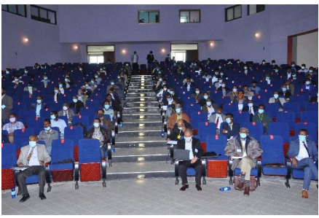
Conference participants (picture provided by EEA).

The 18th International Conference on the Ethiopian Economy, organized by the Ethiopian Economics Association (EEA), took place from July 23-24, 2021. About 450 participants, gathered from various parts of the country and abroad, attended the conference in person and virtually. During the event, a total of 33 papers were presented. The lectures were organized in four sub-themes: Agriculture, Energy, Environment, and Macro-economy. Also, the conference featured panel discussions on two topical national agendas: the first talked about the “Economic Contribution of the Great Ethiopian Renaissance Dam (GERD)” to downstream countries and its potential as a growth model for the Nile Basin, while the second was on “Current Drivers and Transmission Mechanisms of Inflation in Ethiopia”. Furthermore, there were presentations by experts from partner agencies including UCL Energy Institute, LSMS-World Bank, International Growth Center (IGC), and International Food Policy Research Institute (IFPRI).
During the conference, the Central Statistics Agency and the LSMS team disseminated survey and research activities from the Living Standards Measurement Study-Integrated Surveys on Agriculture (LSMS-ISA) project, to provide basic information on the LSMS-ISA program in Africa as well as detailed content and implementation arrangements of the Ethiopia Socioeconomic Survey (ESS1, ESS2, ESS3 & ESS4) and the Ethiopia High-Frequency Phone Survey of Households (HFPS-HH). The ESS information also covered survey experiments conducted in different waves and samples of published works using ESS data, to demonstrate the advantages of direct measurement over self-report with an example from the ESS drinking water quality module. It was also indicated how the ESS sex-disaggregated data facilitated research on gender-differentiated outcomes. The information shared with the participants on the HFPS-HH included the linkages between the phone survey and the latest wave of ESS, especially on how the latest round of ESS was leveraged to design a phone survey to quickly respond to the immediate data needs to monitor the socioeconomic impacts of COVID-19 on households. Finally, conference participants were informed where and how to access the ESS and HFPS-HH open data and supporting documentation available at the World Bank’s Microdata Library.

* The International Conference on Ethiopian Economy is organized annually by the Ethiopian Economics Association. The event is attended by policy advisors and researchers from academia and regional and international research institutions.

