PROCUREMENT GUIDANCE

Finding business opportunities and winning contracts financed by the World Bank

October 2021

Published April, 2018
Reprint September, 2019
Reprint October, 2021

Copyright © 2021
The World Bank
1818 H Street NW
Washington DC 20433
Telephone: 202-473-1000
Internet: www.worldbank.org
Disclaimer
This work is a product of the staff of The World Bank. The findings, interpretations, and conclusions expressed in this work do not necessarily reflect the views of The World Bank, its Board of Executive Directors, or the governments they represent.
Rights and Permissions
The material in this work is subject to copyright. Because the World Bank encourages dissemination of its knowledge, this work may be reproduced, in whole or in part, for noncommercial purposes as long as full attribution to this work is given. Any queries on rights and licenses, including subsidiary rights, should be addressed to:
Office of the Publisher
The World Bank
1818 H Street NW
Washington, DC 20433
USA
fax: 202-522-2422
e-mail: pubrights@worldbank.org.

Common Abbreviations and Defined Terms

This section explains the common terms and abbreviations used in this Guidance. Defined terms are written using capital letters.
Abbreviation / term | Full terminology / definition
BAFO | Best and final offer.
Bank | IBRD and/or IDA (whether acting on its own account or in its capacity as administrator of trust funds provided by other donors).
Beneficial Ownership | Individuals or organizations who have a controlling interest in the company.
Bidder | A firm or joint venture that submits a Bid for Goods, Works, or Non-Consulting Services.
Borrower | A Borrower or recipient of Investment Project Financing (IPF) and any other entity involved in the implementation of a project financed by IPF.
Business Day | Any day that is an official working day of the Borrower. It excludes the Borrower’s official public holidays.
Buyer | The implementing agency of the Borrower, unless the procurement is for the Bank itself – this will be clearly identified to the Seller.
Corporate Procurement | The internal procurement team and processes used when the Bank is buying for its own use.
Consultant | A variety of private entities, joint ventures, or individuals that provide services of an advisory or professional nature. Where the Consultant is an individual they are not engaged by the Borrower as an employee.
Consulting Services | Covers a range of services that are of an advisory or professional nature and are provided by Consultants.
Country Partnership Framework (CPF) | Country Partnership Framework, the central tool of the World Bank Management and the Board for reviewing and guiding its country programs and gauging their effectiveness. The CPF identifies the key objectives and development results through which the World Bank intends to support a member country in its efforts to end extreme poverty and boost shared prosperity in a sustainable manner.
Direct Payment | Direct Payment helps facilitate payments direct from the Bank to contractors.
GGP | Governance Global Practice, the Bank’s Global Practice within the Equitable Growth, Finance and Institutions Vice Presidency that is responsible for the Director, Practice Managers, Procurement Specialists etc. that support Operations Procurement in Bank Task Teams.
Goods | A category of procurement that includes: commodities, raw materials, machinery, equipment, vehicles, plant etc.
IBRD | International Bank for Reconstruction and Development
ICSID | International Centre for Settlement of Investment Disputes.
IDA | International Development Association.
IFB | Invitation for Bids.
IFC | International Finance Corporation.
ITB | Invitation to Bid.
Investment Project Financing (IPF) | The Bank’s financing of investment projects that aims to promote poverty reduction and sustainable development. IPF supports projects with defined development objectives, activities, and results, and disburses the proceeds of Bank financing against specific eligible expenditures.
MIGA | Multilateral Investment Guarantee Agency.
MOS | Monthly Operational Summary.
Non-Consulting Services | Services which are not Consulting Services. Non-Consulting Services are normally Bid and contracted on the basis of performance of measurable outputs, and for which performance standards can be clearly identified and consistently applied e.g. drilling, aerial photography, satellite imagery, mapping etc.
Operations Procurement | Procurements financed under IBRD or IDA loans, using the Bank’s Procurement Regulations led by the implementing agency of the Borrower.
OPCS | Operations Policy and Country Services, the Bank’s Vice Presidency that is responsible for the Chief Procurement Officer and team of Procurement Policy Specialists that set the overall Bank Procurement Framework.
PAD | Project Appraisal Document.
PID | Project Information Document.
PPSD | Project Procurement Strategy for Development.
Procurement Regulations | The World Bank’s Procurement Regulations for Investment Project Financing. These Regulations set the rules for how procurements under IPF are handled.
Proposal | An offer, in response to a request for proposals, which may or may not include price, by one party to provide Goods, Works, Non-Consulting Services or Consulting Services to another party.
Request for Bids (RFB) | Request for Bids is a competitive method for the solicitation of Bids. It is used when the nature of the Goods, Works, or Non-Consulting Services to be provided, the Borrower is able to specify detailed requirements to which Bidders respond in offering Bids.
Request for Proposals (RFP) | Request for Proposals is a competitive method for the solicitation of Proposals. It is used when the nature and complexity of the Goods, Works, or Non-Consulting Services to be procured, the Borrower’s business needs are better met by allowing Proposers to offer customized solutions or Proposals that may vary in the manner in which they meet or exceed the requirement of the RFP.
Request for Quotation (RFQ) | Request for Quotation is a competitive method that is based on comparing price quotations from firms.
Seller | Contractors, suppliers, firms, Consultants and non-government organizations who wish to sell Goods, Works, Consulting or Non-Consulting Services.
SOE | State-owned Enterprise or institution.
SPD | Standard Procurement Document.
Task Team | The team headed by Task Leaders and including procurement-accredited staff) are responsible and accountable for project-level procurement support and procurement monitoring activities.
TL | Task Leader.
UNDB | United Nations Development Business.
VfM | Value for Money.
Works | A category of procurement that refers to construction, repair, rehabilitation, demolition, restoration, maintenance of civil work structure, and related services such as transportation insurance, installation, commissioning, and training.
World Bank | The World Bank comprises two WBG institutions, namely the International Bank for Reconstruction and Development (IBRD), which assists middle-income and creditworthy poorer countries; and the International Development Association (IDA), which focuses on the world’s poorest countries.
World Bank Group (WBG) | The World Bank Group is a unique global partnership of five institutions working for sustainable solutions that reduce poverty and build shared prosperity in developing countries. The five institutions are IBRD, IDA, IFC, MIGA and ICSID.

Contents

Section I. Overview 1
Purpose 1
Types of business opportunities 1
Sources of business opportunities 1
Tools for Sellers 2
Section II. World Bank Group 3
Overview 3
Institutions 3
World Bank 3
World Bank Group 4
Structure 4
Regions 5
Summary 5
Section III. Operations Procurement 7
Overview 7
Benefits of selling to Bank financed projects 8
Investment Project Financing 8
When business opportunities arise 9
Bank’s Project Cycle 9
Targeting business opportunities 12
Tools to help target business opportunities 13
1. Country Partnership Frameworks (CPF) 13
2. Monthly Operational Summary (MOS) 14
3. World Bank website 15
4. WBG Finances 17
5. Project Procurement Application 18
6. UNDB website 18
7. Engage with the Borrower or Bank Task Leader 19
Bank roles and responsibilities 19
1. Task Leaders 19
2. Global Practice Specialists 20
3. Country Officers 20
4. Procurement Specialists 20
Bank Guidelines versus Regulations 21
Procurement Framework 21
The four parts of the Procurement Framework 21
Procurement Regulations 23
Exceptions to the Procurement Regulations 23
Core procurement principles 23
Eligibility 25
General rule 25
Exceptions to general rule 25
State-owned Enterprises or Institutions 26
Anti-corruption 26
Procurement process 26
Fit-for-purpose procurement 27
Market analysis and procurement strategy 28
Procurement Plan 29
Standard Procurement Documents (SPDs) 29
Publication of procurement opportunities 29
Language 30
Changes to procurement documents 30
Opening Bids/Proposals 30
Evaluation 30
Decision to award and Standstill Period 31
How to complain 32
Beneficial Ownership 33
Direct Payment 33
More information 33
Section IV. Corporate Procurement 34
Overview 34
Targeting opportunities 34
Corporate Procurement principles 35
Procurement policies and procedures 35
Procurement process 36
Sourcing methods 36
Participating in the solicitation process 36
Disclosure of contract awards 37
Vendor Risk Management 37
Business ethics 37
Sustainable Procurement 37
Environmentally Responsible Procurement 38
Supplier Diversity 38
Eligibility 38
How to complain 38
Other information 39
Annex A. Operations Procurement – Tips for Bidding 40
Annex B. Operations Procurement – Bidding checklist 42
Annex C. Operations Procurement – Data FY21 44
Annex D. Operations Procurement – Who’s who 46
Annex E. Corporate Procurement – Tips for Bidding 50
Annex F. Corporate Procurement – What we buy 52
Annex G. Corporate Procurement – Data for FY21 55
Annex H. Corporate Procurement – Who’s who 57
Annex I. Sources of useful information 59

Section I. Overview

Section I. Overview

Purpose
This guidance is written for contractors, suppliers, firms, Consultants and non-government organizations (generically termed “Sellers”) interested in winning contracts for World Bank (Bank) financed projects or selling directly to the World Bank Group (WBG).

Types of business opportunities
Securing a Bank financed contract can be a great way to expand your business, build international experience and make a positive contribution to global development outcomes.
This guidance describes two types of business opportunities that are available to Sellers, namely:
- Operations Procurement;
- Corporate Procurement.
It outlines the different procurement procedures that apply to each. It is designed as an introduction and overview only. Interested Sellers are advised to study the appropriate World Bank procurement policies and procedures relevant to each procurement opportunity – links are provided throughout this Guidance.

Sources of business opportunities
Broadly, there are two sources of business opportunities:
Operations Procurement: These opportunities arise in relation to the implementation of international development projects financed by the World Bank. Finance is provided to Borrowers (Bank clients), through Investment Project Financing (IPF). In Operations Procurement the Borrower is the Buyer, not the Bank. However, the Borrower is required to follow the Bank’s Operations Procurement rules when tendering, letting and implementing these contracts. These rules are split into two types:
- the Bank’s previous Procurement Guidelines for Goods, Works and Non-Consulting Services, and Consultant Guidelines for the selection and employment of Consultants;
- the new Procurement Framework.
The Bank finances between US$10 to $17 billion worth of Operations Procurements annually, across 144 countries.
Corporate Procurement: These opportunities arise when the World Bank Group (WBG) wishes to purchase the Goods, Works, or Services it needs in order to operate. These include Consulting Services to support the WBG’s lending operations. In Corporate Procurement the WBG is the Buyer. This procurement is handled by the Bank’s Corporate Procurement Division, with some contracting being done by in-country office staff. Corporate Procurement has its own procurement policies and procedures which are separate from, and different to Operations Procurement.
This guidance is presented in two parts:
- Part 1 deals with Operations Procurement (Section III - page 7);
- Part 2 deals with Corporate procurement (Section IV - page 33).

Tools for Sellers
There are various sources of information, apps and other tools available that help Sellers identify and participate in business opportunities at the Bank. Links are provided throughout this guidance.

Section II. World Bank Group
Section II. World Bank Group

Overview
The World Bank Group (WBG) is one of the world’s largest sources of funding and knowledge for developing countries. The WBG has two goals;
- To end extreme poverty; and
- Promote shared prosperity in a sustainable way.
Conceived in 1944 to reconstruct war-torn Europe, the WBG has evolved into one of the world’s largest sources of development assistance. With 189-member countries, staff from more 170 countries, and offices in over 140 locations, the WBG is a unique global partnership.

Institutions
The WBG comprises five institutions. These institutions work together for sustainable solutions that reduce poverty and build shared prosperity in developing countries.

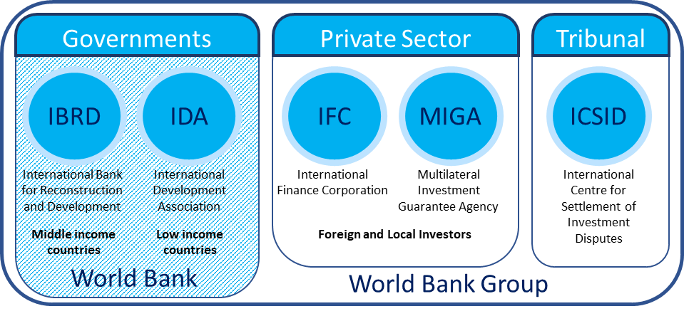

Figure I – The World Bank Group institutions

World Bank
The World Bank (as opposed to the WBG), comprises two WBG institutions, namely:
- International Bank for Reconstruction and Development (IBRD), which assists middle-income and creditworthy poorer countries; and
- International Development Association (IDA), which focuses on the world’s poorest countries.
The World Bank provides loans to governments of developing countries. These primarily fund capital programs. In addition, the World Bank provides policy advice, and technical assistance to support governments when implementing development projects. The Bank's assistance plans are based on poverty reduction strategies. From an extensive analysis of a country's financial and economic situation each country identifies its priorities and targets for the reduction of poverty and national development. The World Bank aligns its aid efforts correspondingly.

World Bank Group
The World Bank is part of the wider WBG. The remainder of the World Bank Group includes an additional three institutions that focus on strengthening the private sector in developing countries. These institutions are:
- International Finance Corporation (IFC);
- Multilateral Investment Guarantee Agency (MIGA); and
- International Centre for Settlement of Investment Disputes (ICSID).

Structure
The WBG operates like a cooperative. It has 189-member countries. Member countries are shareholders in the Bank. The shareholders are represented by a Board of Governors.
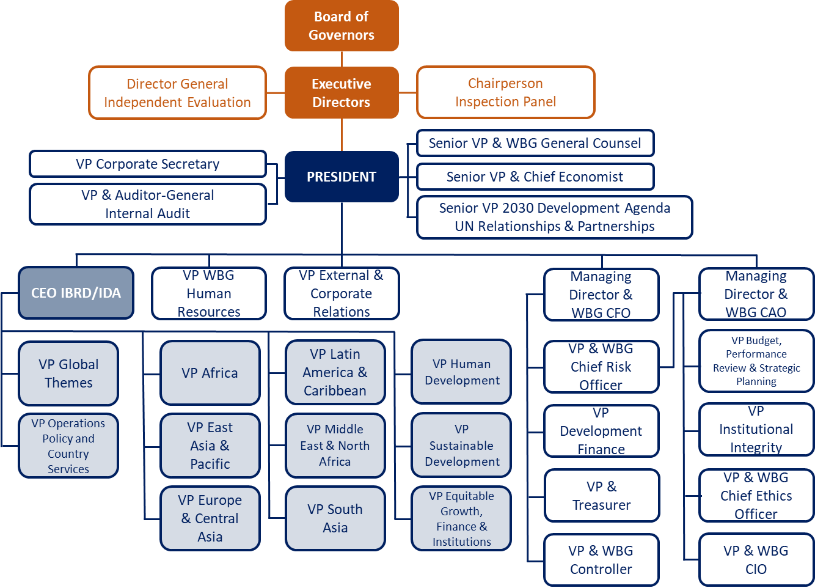
The Board is responsible for setting policy. Generally, the Governors are member countries represented by their ministers of finance or ministers of development. The Governors meet once a year at the Annual Meetings of the Boards of Governors of the World Bank Group and the International Monetary Fund.
Figure II - WBG Organizational Chart
The Board appoints the President, who chairs meetings of the Board and is responsible for overall management of the WBG. The Board delegates specific duties to 25 Executive Directors, who work on-site at the WBG. The Executive Directors normally meet twice a week to oversee the WBG’s business, including approval of loans and guarantees, new policies, the administrative budget, country partnership frameworks and borrowing and financial decisions.
Day-to-day operations are organized by place (region), and subject (Global Practice, function or Cross Cutting Solution Area). This is managed through Vice Presidents in charge of Global Practices, Cross-Cutting Solutions Areas, regions, and functions.

Regions
The World Bank’s headquarters are in Washington, D.C. It provides financing and support to projects in 144 countries. Its operations are divided into six geographic regions (identified in Figure III below).
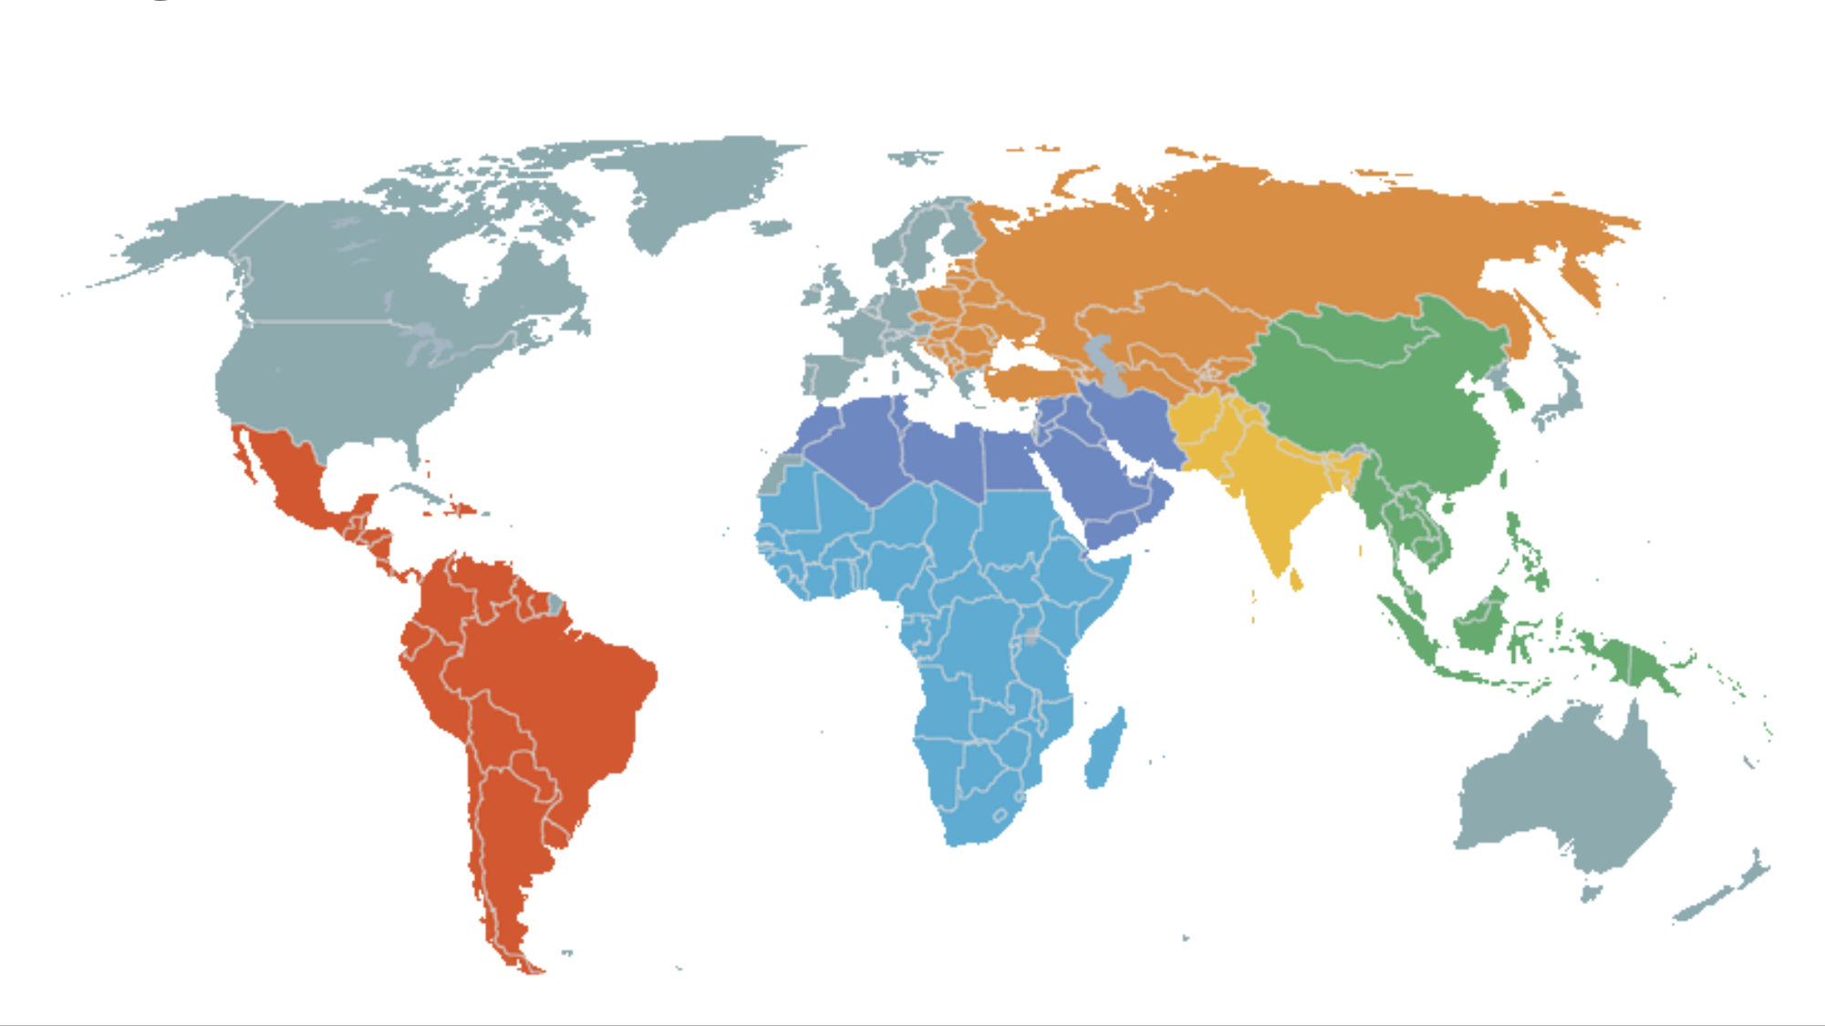
Note: areas in grey are non-borrowing countries

Latin America and the Caribbean (LAC) | Europe and Central Asia (ECA)
Middle East and North Africa (MENA) | South Asia (SAR)
Africa (AFR) | East Asia and Pacific (EAP)
Figure III - WBG Regions

Summary
The WBG presents a variety of business opportunities for a diverse range of Sellers. Understanding the WBG, how it is structured and how it operates will increase a Seller’s chances of identifying the right business opportunities and winning contracts.
Learn how to find opportunities and understand the procurement processes in Section III (Operations Procurement) and Section IV (Corporate Procurement). Find out who’s who in WBG procurement in Annex D (Operations Procurement) and Annex H (Corporate Procurement). Read how to increase your chances of winning contracts in Annex A (Operations Procurement – Tips for Bidding), Annex B (Operations Procurement – Bidding Checklists), and Annex E (Corporate Procurement – Tips for Bidding).

Section III. Operations Procurement

Section III. Operations Procurement

Overview
Operations Procurement refers to the procurements undertaken when implementing World Bank (IBRD/IDA) funded international development projects. World Bank finance for procurements is provided to Borrowers through Investment Project Financing (IPF). In Operations Procurement the Borrower is the Buyer. When a Seller wins one of these procurements the contract is with the Borrower, not the Bank.
Through IPF, the World Bank finances about US$17 billion worth of Operations Procurements annually, across 144 countries. Operations Procurements occur in diverse locations and sometimes in challenging operating environments. Procurements range from simple and routine Goods and Services to complex major projects. Types of major projects include:
- Highly complex infrastructure e.g. railways, power stations, water treatment plants;
- Consultancy Services e.g. engineering design and supervision, tax collection advice, research and development;
- Major plant and equipment e.g. generators, wind turbines, pumps, rail stock;
- High tech information technology e.g. computers, mobile phone networks;
- Non-Consulting Services e.g. aerial surveying, cartography, site investigations; and
- Critical supplies e.g. emergency medical supplies, shelters, food.
In addition to providing IPF to fund projects, the World Bank provides:
- Capacity building;
- Implementation support; and
- Monitoring and procurement oversight of the Borrower’s procurement activities.
Operations Procurement opportunities are overseen by the World Bank, mainly through the Bank’s regional teams, or its global practice units. As projects arise they are allocated to a Task Leader (TL), usually based in the country that is responsible for implementing the project. In fulfilling this function, the Bank takes a risk-based approach.

Benefits of selling to Bank financed projects
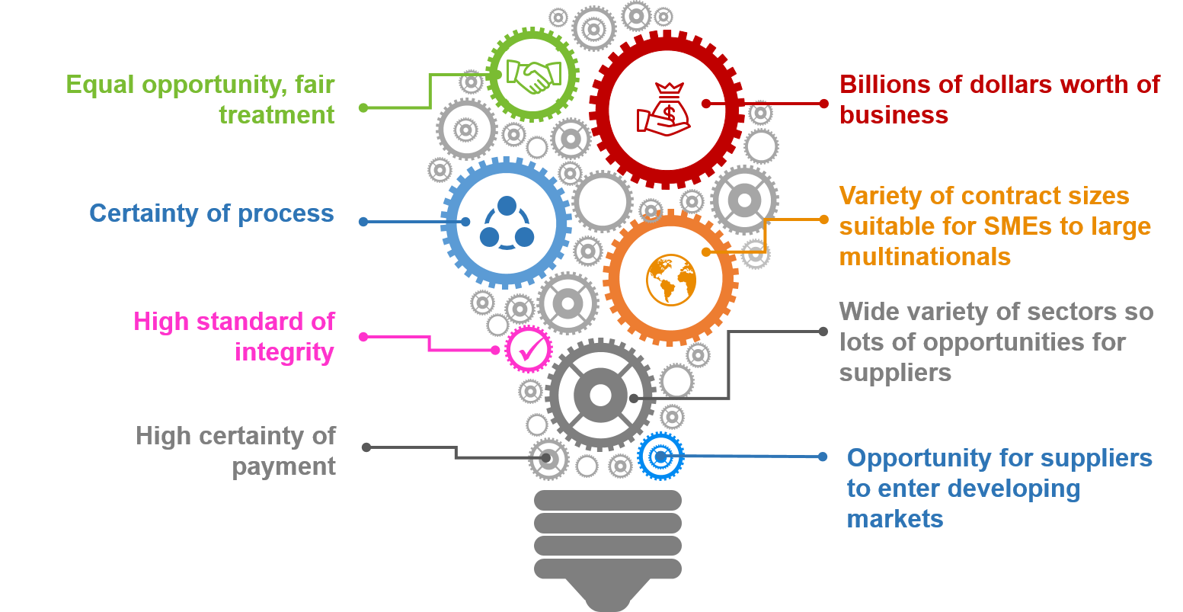
There are many benefits of selling to World Bank financed Operations Procurements.
Figure IV - Benefits of selling to Bank financed Operations Procurement
IPF projects themselves can be interesting, cover a wide variety of Goods, Works, Consulting and Non-Consulting Services, and provide unique opportunities to support the delivery of the World Bank’s development agenda. The types of business opportunities vary in scope, value and complexity and are suitable for delivery by a range of Sellers from SMEs through to large multi-national companies. Contracts are delivered across the globe and provide opportunities for both domestic and international Sellers. Contracts can be short, medium or long term.
Being awarded a World Bank funded contract can be a good, lower risk way to enter a developing market, especially if you are new to working in the development sector or that country.

Investment Project Financing
World Bank financing is provided to countries through Investment Project Financing (IPF). This can take the form of an IBRD loan, or IDA credit, grant and guarantee. IPF leads to many business opportunities for Sellers of Goods, Works, Consulting and Non-Consulting Services.
Unlike commercial lending, World Bank IPF not only supplies Borrowers with needed financing, but also serves as a vehicle for sustained, global knowledge transfer and technical assistance. This includes wrap around support in analytical and design work at the conceptual stages of project preparation, technical support and expertise during implementation (including in the areas of project management and fiduciary and safeguards activities), and institution building throughout the project.

When business opportunities arise
To understand how business opportunities arise in Operations Procurement, it is helpful to be familiar with the World Bank’s processes for granting and administering IPF. The key steps in this project funding process are captured in the Bank’s project cycle.

Bank’s Project Cycle
The Bank provides support, oversight and supervision as projects progress through the various stages of the project cycle.
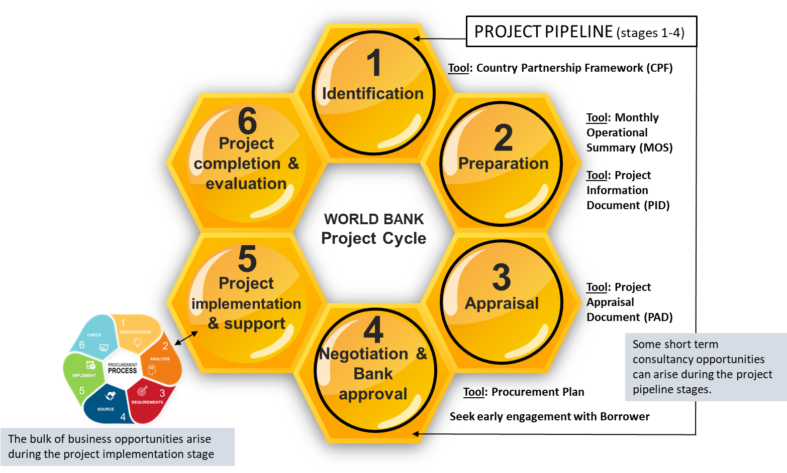
Figure V – World Bank’s project cycle
The first four stages of the project cycle are collectively known as the “project pipeline”. This pipeline comprises projects at various stages of development, before obtaining Bank approval for funding, and before going to procurement at the implementation stage (stage 5).
Projects in the “pipeline” can generate consulting opportunities. Such Consultants may be engaged directly by the World Bank or by the Borrower. Where the World Bank engages Consultants, depending on requirements, it is done through either the Bank’s Corporate Procurement procedures (see Section IV, Corporate Procurement), or as part of the Bank’s HR function (where specialists are hired as individual Short-Term Consultants (STCs)).
The bulk of business opportunities occur at the project implementation stage (stage 5). This is when the Borrower undertakes procurements to implement the project. Depending on the nature of the project, this can generate a variety of large and small procurements to purchase Goods, Works, plant, equipment, Consulting and Non-Consulting Services.
It must be noted that Consultants engaged during the project pipeline stages may be precluded from being hired by the Borrower on the same project during implementation due to possible conflict of interest or unfair advantage, unless such conflict of interest or unfair advantage has been resolved in a manner satisfactory to the Bank.
The following describes the processes during the project cycle and identifies the key business opportunities that can arise.
Stage | Procurement process and business opportunities
STAGE 1  Identification | - During this stage, the country government, and the Bank, are involved in analyzing and developing strategies for the Borrower’s economy as a whole, and in identifying projects that support those strategies.  - When the project identification is completed, a Project Information Document (PID) is published on the World Bank’s Project Database.  - The PID includes contact information for the Borrower’s project implementing agency, as well as identifying the Bank’s TL.  - The Bank may seek Consultants to aid its identification analysis. For consulting firms, these opportunities may be advertised on the Bank’s business opportunities website (see Part 2, Corporate Procurement) where the Bank’s own Corporate Procurement rules apply. Consultants may also be hired as individual Short-Term Consultants (STCs). This is managed by the Bank’s HR function, applying the Bank’s HR rules.
STAGE 2  Preparation | - The Borrower is responsible for the work done at the preparation stage. This is when the technical and institutional alternatives for achieving a project's objectives are identified and discussed.  - Preparation usually requires feasibility studies followed by more detailed studies of the alternatives that promise to yield the most satisfactory results. An environmental assessment is usually carried out during this phase.  - At this time Borrowers may supplement their own efforts by engaging Consultants to carry out parts of the work. Depending on the value, these procurements will be advertised on the United Nations Development Business website (UNDB).  - Market analysis and preparation of procurement strategies (i.e. the Project Procurement Strategy for Development (PPSD)) usually start at this stage. During market analysis the Borrower will research the supply market to identify: the number and types of Sellers available (nationally and/or internationally, if appropriate), pricing structures, total costs of ownership, and new or emerging solutions or technologies. The Borrower may also test its proposed solution by undertaking market soundings and getting feedback from Sellers. Such direct engagement with the market at this early stage needs to be carefully managed to ensure that it is done in a fair and transparent way and does not advantage or disadvantage one Seller over another. Thresholds for procurement approaches and methods vary by category and country. For details see Bank Guidance: Thresholds for procurement approaches and methods by country.
STAGE 3  Appraisal | - At the appraisal stage the Bank is responsible for undertaking a comprehensive review of all aspects of the project (technical, institutional, economic, and financial). This lays the foundation for implementing the project and evaluating it when completed.  - At the end of Stage 3, a Project Appraisal Document (PAD) is published and is available on the World Bank website.  Project appraisals are conducted by Bank staff. In addition, staff may be supplemented by individual Consultants who are experts in relevant fields.  - Market engagement can take place in this stage as details of the procurement approaches to deliver the project are included in the PAD. The Borrower may engage with the market as part of market research to ensure that the Borrower has developed procurement approaches that fit with the market.  - Market engagement can be done in a number of different ways including: concept viability exercises, Seller questionnaires, market sounding exercises, Seller conferences, trade events, paid for market research, and publication of preliminary (outline) procurement strategies for consultation.  - For consulting firms, these opportunities may be advertised on the Bank’s business opportunities website, using the Bank’s Corporate Procurement rules, or hired as STCs using the Bank’s HR rules.  - At this stage, some Borrowers may start procurement before the Bank loan has been approved. This is called “advance procurement”. Such opportunities are advertised on the UNDB website.
STAGE 4  Negotiation and Bank approval | - During stage four the Bank and Borrower negotiate the IPF. The agreement reached is recorded in the draft loan, credit or grant documents.  - These documents are required for IPF funded projects. The Bank reviews the PPSD and Procurement Plan as part of the project appraisal. The Bank and Borrower agree the Procurement Plan no later than completion of loan negotiations.  - Upon completion of negotiations, the project is then presented to the Executive Directors of the Bank for their consideration and approval. Following approval, the loan, credit or grant agreement is signed.
STAGE 5  Implementation | - Following Bank approval, the loan, credit or grant is declared effective. Implementation gets underway normally a few months after signing.  - Contract opportunities during the project implementation stages are called Operations Procurement. This procurement is led by the Borrower, who is the Buyer. The Procurement Plan (which outlines the planned procurements, their estimated costs and scheduling) is published on the World Bank website. A General Procurement Notice is also published on the UNDB and World Bank website.  - Early in the implementation stage is a good time to engage with Borrowers to express your interest in specific projects. You can request information on what Goods, Works, Consulting or Non-Consulting Services will be needed, when these opportunities are likely to be advertised, and when and how to submit Bids or Proposals.

Targeting business opportunities
It is important to target opportunities that reflect your business offering and identify the countries where you are most interested in doing business. This will make it easier to engage with the most appropriate Borrower implementing agency or part of the Bank and find the right person to talk to.
Subject: If you know the subject area you are interested in, then you can engage with the Global Practice or Cross Cutting Solution Area team at the Bank.
Place: If you know the place you are interested in, you can engage with the relevant Borrower or Borrower agency. You may also engage with the Bank region, and/or country office (that will often house the subject matter expert).
Once the subject or place are identified, Sellers can check the World Bank website (projects and operations) to find projects of interest. This webpage allows you to browse by country/area, sector or Procurement Plan.
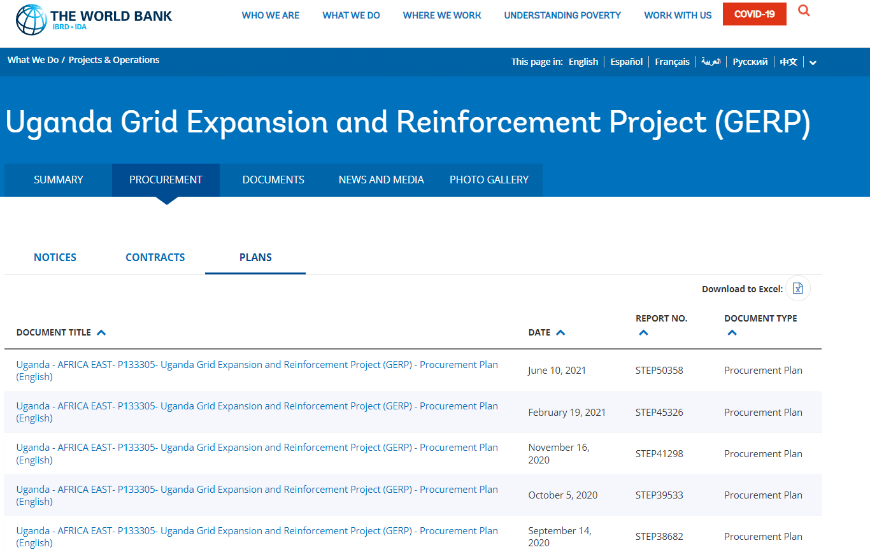
Figure VI - Example listing from Bank Projects and Operations webpage

Tools to help target business opportunities
There are a variety of available tools to help target opportunities. Understanding what these tools are and how to use them will make it easier to find projects of interest.

1. Country Partnership Frameworks (CPF)
Once you have identified the country(ies) you are interested in working in, you can access information on what projects and procurement opportunities are likely to arise by reading the Country Partnership Frameworks (CPFs). CPFs are publicly available for download.
The CPF identifies the key objectives and development results through which the WBG intends to support a member country in its efforts to end extreme poverty and boost shared prosperity in a sustainable manner. A CPF addresses the most important challenges and opportunities a country faces in advancing towards the Bank’s twin goals of ending extreme poverty and increasing shared prosperity in a sustainable manner. It is developed in partnership between the Bank and the country and is based on a model which is systematic and evidence-based. During preparation of the CPF, the Bank may engage with businesses in the country to seek their views. The CPF typically covers a 5-year period and details an indicative pipeline of future projects (which lead to future procurements).
Indicative FY16-20 IDA Lending Program
Fiscal Year | Project Name | Amount  (US $ million)
IDA 17  FY16-17 | Skills and Training Enhancement (AF) | 100
 | Siddhirganj Power (AF) | 176
 | Ghorashal 4 Power Generation | 217
 | Private Sector Development (AF) | 130
 | River Management Improvement 1 | 600
 | Pro-poor Slums Integration | 50
 | Regional Waterways | 170
 | Colleges | 100
 | Modernization of State-owned Financial Institutions | 150
 | Insurance and Pensions | 80
 | Regional Weather and Climate Services | 75
 | Public Procurement Reform II (AF) | 9
 | Leveraging ICT (AF) | 26
 | Health Sector Development Program (AF) | 150
 | TOTAL | 2,033
Note: pipeline project amounts are provisional and subject to change
Table I - Example listing from CPF
In the above hypothetical example, projects would then be developed that support the agenda, for example:
- Project P1234A on Health Sector Development Program (AF) including procurement of:
  - new hospital design, construction and supervision;
  - existing hospital refurbishment;
  - large medical diagnostic imaging equipment e.g. MRI’s, X-Ray etc.; and
  - medical staff training/education.
- Project P1236 leveraging ICT (AF), including procurement of:
- establishing a data center including providing ICT equipment;
- design and installation of a cloud infrastructure solution;
- establishing an e-government platform; and
- training and advice to tax collectors and auditors.
Then, once identified in the CPF, projects proceed through the rest of the project pipeline (stages 1 to 4 in the Project Cycle, Figure V, page 9). Projects in the pipeline are tracked and publicly reported in a Monthly Operational Summary (see below) that details the status of each project.

2. Monthly Operational Summary (MOS)
The Monthly Operational Summary (MOS) reports on the status of projects while they are in the project pipeline. Projects appear in the MOS from the point they are identified up to the signing of the loan or credit agreement (stages 1 to 4 in the Project Cycle, Figure V, page 9). After loans or credits are signed, entries for projects are dropped from the MOS. For Sellers this is a valuable summary of upcoming opportunities.
Kenya | Country
Water and Sanitation | Sector
(R) Mombasa Water and Sanitation: The project seeks to (a) develop ground water sources; (b) improve the transmission line between Baricho Well Field and Mombasa; and (c) provide emergency measures to improve distribution systems and reduce unaccounted for water. | (R) Indicates a revision from the previous month  Title and project description.
Project preparation is underway. Environmental Assessment Category to be determined. | Stage in processing and Environmental Assessment Category.  Italic text indicates a change from previous month
PID: 96367 | Project ID, a unique Bank control number for each project, appears in the MOS when the PID is available at InfoShop.
US $30.0 (IDA). Consulting Services to be determined. | Amount of loan, credit or grant (US $ million).
National Water Conservation and Pipeline Corporation, Workshop Road and Commercial Street, PO Box 30173, Nairobi, Kenya, Tel: (254-2) 555-600, Fax: (254-2) 545-882, E-mail:acnjk@cbs.go.ke, Contact: Mr Andrew Roberts, Managing Director. | Name, address, phone, fax, E-mail address, and name and title of contact person of the implementing agency.
Table II - Example listing from MOS
Sellers should scan read the MOS report for each region of interest and identify project opportunities to pursue. Sellers may at this stage engage with Borrowers and the Bank country office for further details of upcoming projects.

3. World Bank website
Once you have identified the countries or sectors of interest, you can visit the World Bank projects and operations website to identify specific projects of interest. The website allows you to search by country or subject to focus your search to relevant projects.
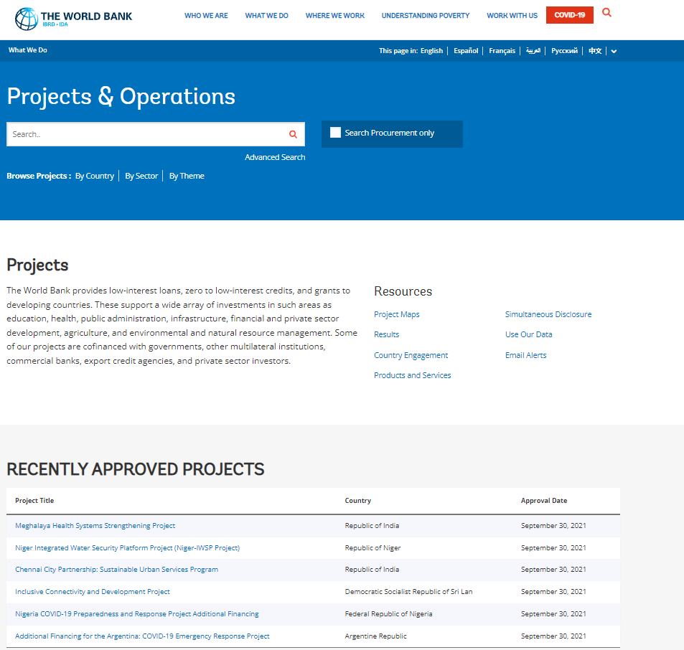
Figure VII - Example of Projects and Operations listed on the Bank website
Under each project of interest, check the procurement tab to find the following:
- The Procurement Plan for the project which contains:
  - the description of what is to be procured;
  - the cost estimate of the procurement;
  - the selection method; and
  - the timeline for key steps in the process.
- The General Procurement Notice for the project which is published before the procurement commences and contains:
  - the name of the Borrower;
  - the purpose and amount of the financing;
  - the scope of planned procurement under the project; and
  - the Borrower’s contact information in case Sellers wish to express interest in upcoming contracts or to seek further information.
- Procurement/tender notices; and
- Contract award notices.
A typical webpage for a project looks like this:
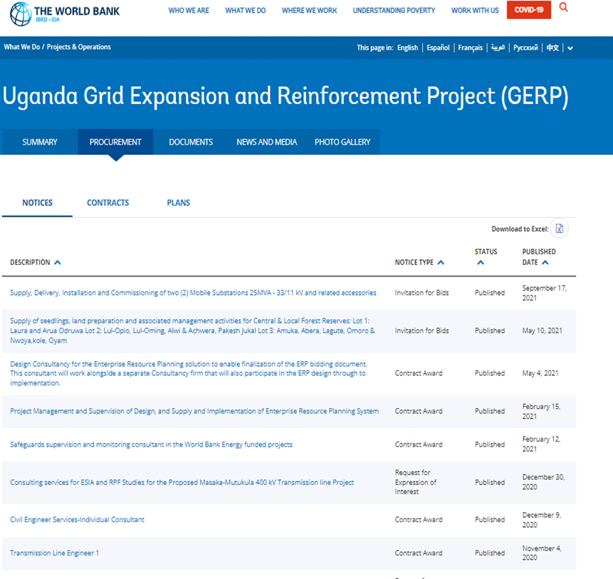
Figure VIII - Example of project details available on the Bank website

4. WBG Finances
WBG Finances is a World Bank Group digital platform that provides our clients and partners access to public financial data and portfolio information from across all Group entities, in one place. Ensuring that information is available in different formats, and recognizing many Seller’s preferences to have easy access to procurement data and information rather than websites to access information, the Bank offers the World Bank Group Finances One. This is an interactive platform to interrogate and analyze WBG financial data. The Finances One platform details all projects the Bank is involved with, from identification through to end of implementation (so it includes both planned projects, as well as projects in progress).
This platform consolidates data from multiple websites. Once you type ‘financesappqa.worldbank.org’ into a browser, it opens the platform and does not require any registration or sign in to begin use.
Through this platform, Sellers can access the Bank’s portfolio of projects, finances, and upcoming key procurement opportunities. This app can be used as follows;
- identify future projects, procurements and business opportunities;
- receive Procurement/Tender Notices and follow business opportunities in more than 100 countries;
- get updates on pending projects in the pipeline, as well as the latest approved projects;
- check the disbursements data, updated monthly, and the contributions to Trust Funds;
- engage with the Bank by sharing, following its projects and investments, or reporting back;
- find the answers to questions such as: where does the Bank’s money go? which countries does the Bank partner with to fund development projects? how much money does the Bank disburse to such projects?;
- access data on prior-reviewed contracts in all active projects - including which firms won contracts in Bank projects and how large these contracts were (data covers from fiscal year 2000 to present);
- see Financial Statements Summaries – the platform also features summaries of the quarterly financial statements for IBRD, IDA, IFC and MIGA.
The Bank will develop a separate guidance document to assist Sellers to make efficient use of this platform to better analyze and find business opportunities. This more detailed guidance will be announced on the Bank’s website.

5. Project Procurement Application
The World Bank’s Project Procurement App allows Sellers to analyze historic procurement data. Sellers should use this App to gather historic information on the types of procurements they are interested in Bidding for. Use this App to examine who is currently winning contracts, where, what for, and for how much? Sellers can use this data to inform their views on the level of competition, and to consider possible partners for joint ventures.
The App presents information for all major prior-reviewed contracts awarded through World Bank investment projects and related trust funds since 1995. The App allows users to search and analyze the data through various visualized queries. All information in the application is public. Sellers may find this data useful to inform their own business development strategy in relation to Bidding on future Bank financed procurements.
The App is made available for free download to all iOS and Android devices. Once the App is installed, it does not require any registration or sign in to begin use. Data is updated in real-time, so information is readily available once connected. Further information can be found in the Procurement Guidance Project Procurement App How to use the World Bank Project Procurement App to Research and Analyze Data.

6. UNDB website
All international competitive procurement opportunities for IPF funded projects are advertised on the UN Development Business website (UNDB). This website contains invitations to Bid, or to express interest for contracts under World Bank-financed projects. Current projects listed in the Finances App and the Project Procurement App link directly to each World Bank UNDB posting.
The UNDB website is produced by the United Nations and provides information on business opportunities generated through the World Bank, regional development banks, and other development agencies. It also re-publishes the Bank’s Monthly Operational Summary (MOS). UNDB is available online by subscription. For more information contact the UN Development Business Liaison Office at Tel: +1 (202) 458-2397 or E-mail: dbhelp@worldbank.org.

7. Engage with the Borrower or Bank Task Leader
The Borrower leads the procurement using the Bank’s Guidelines or Procurement Framework. It is supported from the Bank’s Task Team, which is headed by a TL. Sellers are permitted to engage with the Borrower and/or the TL to discuss future opportunities. As required, the Borrower may also initiate early market engagement to sound out prospective Sellers on interest, possible solutions and the procurement process that will yield the best response and result.
Please see Annex D for who’s who in Operations Procurement, and how to contact the Bank.

Bank roles and responsibilities
A general understanding of the Bank’s roles and responsibilities is helpful in case you need to contact someone for clarification or assistance on a particular project or procurement. For more details on the specific roles and responsibilities see the Bank Directive Procurement in IPF and Other Operational Matters.
From a Seller’s perspective, World Bank staff could be said to fall into four broad categories:

1. Task Leaders
Task Leaders (TLs) are typically subject-matter experts and project management specialists who support Borrowers to develop and implement projects. They coordinate the Bank’s activities on individual projects and are ultimately responsible for hiring individual Consultants to assist the project team. The TL heads the Bank’s Task Team (comprising procurement accredited Bank staff). The Task Team is responsible and accountable for project-level procurement support and procurement monitoring activities, including among other things the following functions:
- carrying out project procurement-related risk assessments, proposing appropriate procurement arrangements, and monitoring the implementation of risk mitigation measures;
- assisting the Borrower in the preparation of the PPSD and Procurement Plan;
- issuing a Bank “no-objection” to a Borrower’s decision that requires procurement clearance;
- reviewing procurement-related complaints;
- monitoring contract management, including carrying out physical inspections;
- monitoring contractual disputes;
- maintaining a filing system for all procurement matters related to the project; and
- providing hands-on expanded implementation support.

2. Global Practice Specialists
Global Practice Specialists are subject-matter experts in fields like education, transport, water, or urban development. These specialists provide technical assistance to TL’s on Bank-financed projects.

3. Country Officers
Country Officers (Country Directors and Managers) are responsible for liaising with Borrowers and for strategically overseeing the Bank's lending portfolio in a specific country. Country officers develop the CPF. Most country officers are based in the country that they represent.

4. Procurement Specialists
TL’s are supported by Bank procurement specialists. See Annex D for contact information. However, depending on the type of procurement needed this support can come from one, or a combination of three different sources as follows:
- Operations Procurement Policy functions are provided through the Operations and Country Services Vice Presidency. This small independent procurement team determines, sets, oversees, monitors, coordinates and reports on the overall Procurement Framework for Bank Operations. This team authors, among other things, the Bank’s Procurement Policy, Directives, Procedures, Procurement Regulations, Guidance and Standard Bidding/Procurement Documents. This team also reviews and clears the most complex procurements in the Bank’s operations portfolio, leading the Operations Procurement Review Committee. This team is led by the Chief Procurement Officer, currently Enzo de Laurentiis, based in Washington D.C.
- Operations Procurement Implementation and Borrower Capacity Building functions are provided through Procurement teams in each region of the Bank. Each region has a team of Operational Procurement subject-matter specialists that among other things support Task Teams to deliver projects and their subsequent procurements, and to build procurement capacity in Borrowers by spearheading procurement reforms, education programs and other development programs. These Procurement Specialists form part of the Task Team that supports Borrowers to deliver procurements under Bank financed projects. Each region’s procurement team is led by a Practice Manager (mainly based in Washington D.C.).
- Corporate Procurement functions (used when the Bank is buying for the Bank) are provided through the Corporate Procurement Division. This team of Procurement Specialists execute procurement activities on behalf of the Bank Group. So, when the Bank needs a consulting firm to help it to appraise a project, conduct a feasibility study, or buy a specific piece of equipment or service for internal use, this is supported by the Bank Group’s own Corporate Procurement team using their own policies and processes.
See http://www.worldbank.org/en/about/corporate-procurement. This team is led by the Chief of Corporate Procurement, currently Kenny Cheung, with teams based in Washington D.C., and Chennai, India.

Bank Guidelines versus Regulations
The Bank recently modernized its Operations Procurement framework. As a result, there are two sets of rules that apply to Bank funded IPF projects. Which set of rules applies depends on when the project was approved by the Bank, i.e. pre or post July 2016.
- Guidelines (pre-July 2016)
IPF projects which were approved prior to July 1, 2016, are governed by the Bank’s previous Procurement Guidelines (for Goods, Works and Non-Consulting Services) and Consultant Guidelines (for the selection and employment of Consultants). There are ongoing projects which are subject to these Guidelines. If you are involved with one of these projects you need to understand, and be familiar with, the appropriate Guidelines as these are different from the Regulations that apply to projects that post-date July 1, 2016.
- Regulations (post-July 2016)
The Bank undertook a review of its Guidelines and issued an updated Procurement Framework. IPF Projects which were approved after July 1, 2016 are governed principally by the Procurement Regulations and the overarching Procurement Framework.

Procurement Framework
The Procurement Framework governs IPF projects approved after July 1, 2016. This framework describes the vision for IPF procurement (Operations Procurement) as:
“Procurement in Investment Project Financing (IPF) supports Borrowers to achieve Value for Money (VfM) with integrity in delivering sustainable development.”

The four parts of the Procurement Framework
In providing IPF the Bank is required to ensure that the funding is used only for the purposes for which the financing is granted. To ensure transparency and integrity the Bank has developed a range of policies and procedures. Taken together, these are called the Bank’s Procurement Framework. The Bank adopted the Procurement Framework on July 1, 2016.
The Procurement Framework comprises:
- Procurement Policy
- Procurement Regulations
- Procurement Directive
- Procurement Procedure
Under the Procurement Framework, there are several innovations to help Borrowers and businesses:
- Planning and strategy: Needs and risks specific to a project are analyzed through a PPSD. This analysis enables the Borrower to have a strategy on how best to engage with the market. The analysis ensures that procurement processes are fit for purpose, allow choice, and are appropriate to the size, value, scope, and risk of the project.
- Value for Money: VfM is a core procurement principle in all procurements financed by the World Bank. This means a shift in focus from the lowest evaluated compliant Bid, to Bids that provide the best overall VfM, taking into account quality, cost (including whole-of-life cost where appropriate), and other factors, as required.
- Approved Selection Methods: There are three main classifications of Approved Selection Methods for Goods, Works and Non-Consulting Services. These are:
- Selection Methods Request for Proposals (RFP), Request for Bids (RFB), Request for Quotations (RFQ) and Direct Selection;
- Selection Arrangements e.g.: Competitive Dialogue, Public-Private Partnerships, Commercial Practices, UN Agencies, e-Reverse Auctions, Community Driven Development etc.;
- Market Approach Options e.g.: open competition, limited competition, direct selection, national or international competition, pre-qualification, initial selection, single-stage process, multi-stage process, Best and Final Offer (BAFO), Negotiation, use of rated criteria etc.
- Procurement Approach: The procurement approach involves designing a fit for purpose procurement process to award contracts that deliver the Project Development Objectives and VfM. This includes the procurement arrangements, procurement risk management, contract strategy, market engagement, specifications/requirements drafting and contract management.
- Abnormally Low Bids/Proposals: If a Bid/Proposal is found to be “Abnormally Low” it is rejected by the Borrower. This can happen where, for example: the Bid price, in combination with other elements of the Bid, is so low that it raises material concerns as to the Bidder’s capability to perform the contract for the offered price. Where the Borrower identifies a potentially Abnormally Low Bid/Proposal, there is a specific process that must be followed. The Borrower must seek written clarification from the Bidder/Proposer. If the Bidder/Proposer fails to demonstrate its capability to deliver the contract for the offered price, the Borrower shall reject the Bid/Proposal.
- Standstill Period: A Standstill Period is a pause in the procurement process following the Notification of Intention to Award and the actual award of the contract. It affords the unsuccessful Bidders/Proposers/Consultants time to consider why they were not successful, and if appropriate, submit a complaint in relation to the decision to award the contract. The Standstill Period is ten (10) Business Days after the transmission of the Notification of Intention to Award. The contract cannot be awarded until the Standstill Period expires, or a duly submitted complaint has been addressed, whichever is later.
- Complaints: The Procurement Framework sets out the procedures that apply to the management of procurement-related complaints. These procedures allow Bidders/Proposers/Consultants opportunities to voice concerns during the procurement process, and before a contract is awarded.
- Contract management: The Bank has greater involvement in contract management for high value and high-risk procurements. This helps to ensure the best possible outcomes and supports problems being resolved quickly.

Procurement Regulations
The Procurement Regulations govern the procurement of Goods, Works, Consulting and Non-Consulting Services for all IPF operations approved after July 1, 2016.
The Procurement Regulations are the detailed rules that Borrowers apply when undertaking Bank funded procurement. Sellers should become familiar with them and ensure they fully understand the Bank’s procedures and requirements before participating in an Operations Procurement opportunity. The Regulations are available in multiple languages (Arabic, Chinese, English, French, Japanese, Portuguese, Russian, Spanish, Turkish, Vietnamese) and can be downloaded from the Bank’s website.

Exceptions to the Procurement Regulations
The are some situations where the Procurement Regulations do not apply.
- The Borrower may use its own national procurement procedures only when the procurement is an approach to the national market (typically used for lower value procurements), and the Bank agrees to this approach. Bank must be satisfied that the Borrower’s procedures uphold and protect open, competitive procurement (see the requirements set out in the Procurement Regulations 5.3 to 5.6).
- In relation to procurements where:
- the Bank provides a guarantee only in respect of the project; and
- the project is funded through loans by financial intermediaries to private Borrowers.
- Where a contract is not financed by the Bank, but it is included in the scope of a Bank financed project, the Borrower may adopt other procurement procedures, but only if the Bank is satisfied:
- that the rules and procedures will ensure that the Borrower carries out the project diligently and efficiently;
- the deliverables are specified to a satisfactory quality;
- the contract will be completed in a timely manner; and
- the price does not have an adverse effect on the economic and financial viability of the project.

Core procurement principles
The Bank’s core procurement principles generally guide the Bank’s decisions when applying the Procurement Regulations.

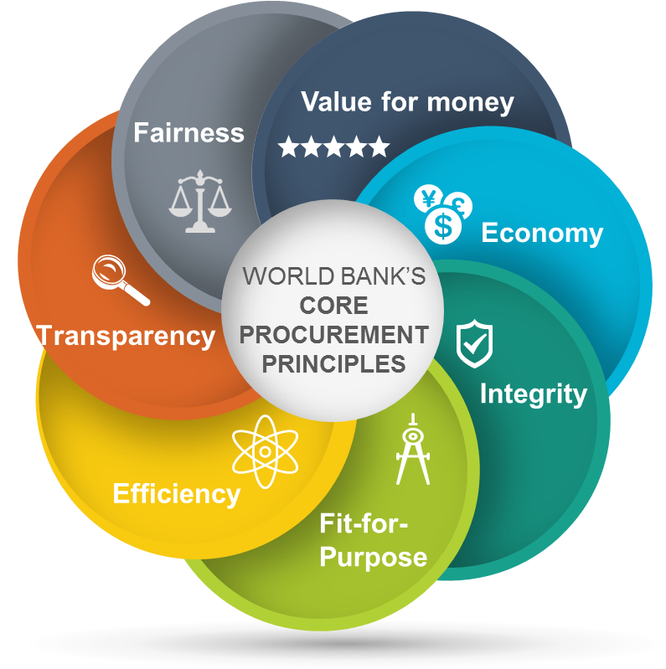
Figure IX – Bank’s Core Procurement Principles
The core procurement principles are:
- Value for Money. The principle of VfM means the effective, efficient, and economic use of resources, which requires an evaluation of relevant costs and benefits, along with an assessment of risks, and non-price attributes and/or life cycle costs, as appropriate. Price alone may not necessarily represent VfM.
- Economy. The principle of economy takes into consideration factors such as sustainability, quality, non-price attributes and/or life cycle cost as appropriate, that support VfM. It permits integrating into the procurement process economic, environmental, and social considerations that the Bank has agreed with the Borrower. It also permits augmenting identified sustainability criteria with specific criteria in support of the Borrower’s own sustainable procurement policy.
- Integrity. The principle of integrity refers to the use of funds, resources, assets, and authority according to the intended purposes and in a manner, that is well informed, aligned with the public interest, and aligned with broader principles of good governance. The Bank requires that all parties involved in the procurement process, and their personnel, observe the highest standard of ethics during the procurement process of Bank-financed contracts, and refrain from fraud and corruption (as defined in the Bank’s Anti-Corruption Guidelines).
- Fit-for-purpose. The principle of fit for purpose applies both to the intended outcomes and the procurement arrangements in determining the most appropriate approach to meet the project development objectives and outcomes, taking into account the context and the risk, value, and complexity of the procurement.
- Efficiency. The principle of efficiency requires that procurement processes be proportional to the value and risks of the underlying project activities. Procurement arrangements are generally time-sensitive and strive to avoid delays.
- Transparency. The principle of transparency requires that the Borrower and the Bank enable appropriate reviews of procurement activities, supported by appropriate documentation and disclosure. Transparency requires:
- that relevant procurement information be made publicly available to all interested parties, consistently and in a timely manner, through readily accessible and widely available sources at reasonable or no cost;
- there is appropriate reporting of procurement activities; and
- confidentiality provisions in contracts are used only where justified.
- Fairness. The principle of fairness refers to:
- equal opportunity and treatment for Bidders/Proposers/Consultants;
- equitable distribution of rights and obligations between Borrowers and suppliers, contractors and Bidders/Proposers/Consultants; and
- credible mechanisms for addressing procurement-related complaints and providing recourse.
Open competitive procurement is the Bank’s preferred procurement approach, whenever possible, to maximize fairness of opportunity to Bid. Whenever possible, the Bank requires that eligible individuals and firms be given the same opportunities to compete for Bank-financed activities.

Eligibility
In order to participate in a procurement opportunity each Seller, and if appropriate the Goods that they supply, must be “eligible”. There are strict rules that govern eligibility. The general conditions that apply to eligibility are contained in the Procurement Regulations (see Procurement Regulations 3.21 to 3.23). The specific conditions that apply to each procurement are detailed in the Bidding/Procurement Documents issued by the Borrower for the procurement.
In general terms, the Bank permits eligible firms and individuals from all countries to offer Goods, Works, Consulting and Non-Consulting Services for Bank-financed projects.
The following descriptions simplify the types of eligibility conditions that generally apply. However, you should refer directly the Procurement Regulations and relevant Bidding/Procurement Documents issued for a particular procurement for the specific eligibility conditions that apply to each business opportunity.

General rule
A Borrower cannot deny a Seller the right to participate in a procurement, or to be awarded a contract, for reasons unrelated to:
- the Seller’s capability and resources to successfully perform the contract, or
- a conflict of interest (see Procurement Regulations 3.14 to 3.17).

Exceptions to general rule
A Borrower can deny a Seller the right to participate, or to be awarded a contract if:
- the Seller is from a country, or the Goods are manufactured in a country, and
- the Borrower’s law or regulations prohibit commercial relations with that country (provided that the Bank is satisfied that the exclusion does not preclude effective competition), or
- if the procurement is to be implemented across jurisdictional boundaries (i.e. the procurement involves more than one country) exclusion of a Seller on this basis by one country, may apply if the Bank, and all of the other countries involved in the procurement, agree, or
- by the act of compliance with a United Nations Security Council taken under Chapter VII, Borrower’s laws prohibit the import of Goods from that country, or prohibits payments to a country, or a person or entity in that country.

State-owned Enterprises or Institutions
State-owned Enterprise or institution (SOEs) of the Borrower’s country are not normally eligible to participate. However, they may be eligible to compete and be awarded contracts in the Borrower’s country if they can establish that they:
- are legally and financially autonomous,
- operate under commercial law, and
- are not under supervision by the agency contracting them.
However, when the Goods, Works, or Services provided by SOEs (including state-owned universities, research centers, or institutions) are of a unique and exceptional nature, or because their participation is critical to the project, the Bank may exceptionally agree to contracting them, on a case-by-case basis. SOEs outside the Borrower’s country are eligible to participate.

Anti-corruption
A firm or individual is not eligible where it has been sanctioned under the Bank’s Anti-Corruption Guidelines and declared ineligible. (see Procurement Regulations Annex IV, Fraud and Corruption).
A Borrower may request that the Bank agree to exclude a firm or individual that is under a sanction of debarment by the judicial or administrative authorities in the Borrower’s country. However, the Bank must be satisfied that the debarment relates to fraud or corruption, and that the judicial or administrative proceeding provided adequate due process.

Procurement process
The procurement process is defined in the Procurement Regulations as:
“the process that starts with the identification of need and continues through planning, preparation of specifications/ requirements, budget considerations, selection, contract award and contract management…”
While each procurement is unique, they broadly follow a similar process. This can be simplified as six key stages. Figure X is a theoretical representation of the procurement process. It shows the common stages and their usual sequencing. Actual procurements may differ.
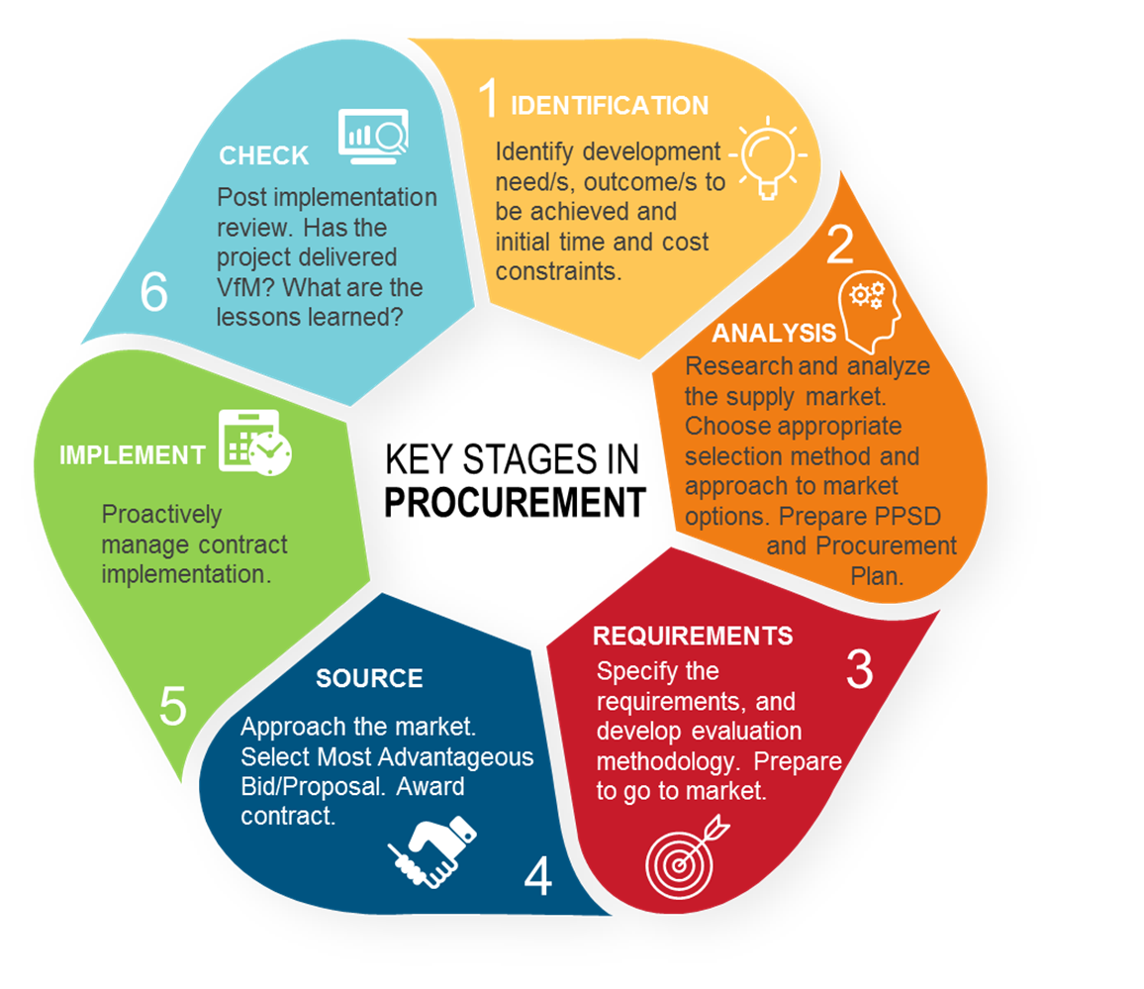

Figure X – Key stages in procurement
Sellers normally focus on stages 4 and 5, which involve the Borrower sourcing the Goods, Works, Consulting or Non-Consulting Services, and awarding and managing the contract.
However, Borrowers may seek to engage earlier with the market, for example: during stages 1 and 2 (project identification and preparing the specification of requirements). The purpose of such early engagement is to carry out market soundings and gain market intelligence to identify what solutions are available or are about to be launched, what technological advances have been introduced, or to identify opportunities for innovation or sustainability. Sellers may also use such opportunities to engage with the Borrower to understand their requirements on upcoming procurement.

Fit-for-purpose procurement
Fit-for-purpose is one of the Bank’s Core Procurement Principles. The Procurement Regulations provide a variety of selection methods, and market approach options. This allows the Borrower a degree of flexibility in designing individual procurement processes that are proportional and fit-for-purpose. (see Procurement Regulations Sections VI and VII). Figure XI provides an example of the types of decisions that a Borrower can make when designing an appropriate procurement process.
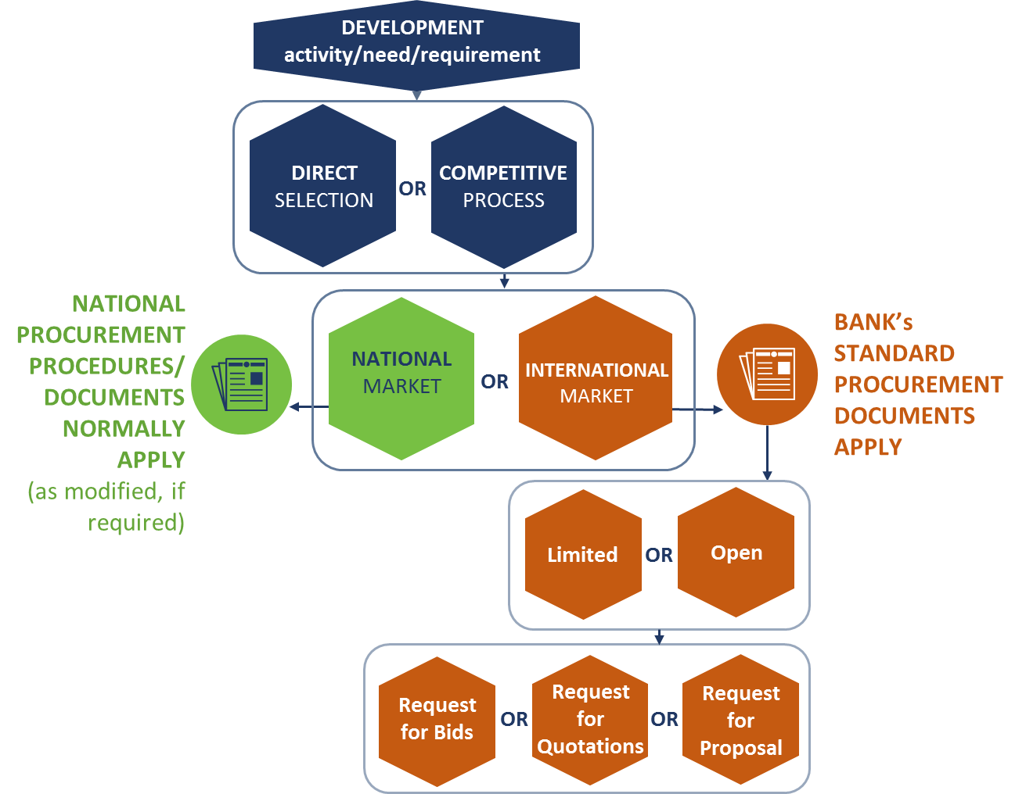
Figure XI – Example of selection methods decision logic

Market analysis and procurement strategy
As part of procurement planning, the Borrower is required to prepare a PPSD for each project financed under IPF. The PPSD is used to determine the optimal way to conduct the procurement to deliver the right procurement result.
Designing the right procurement approach increases the likelihood of the best Sellers submitting Bids/Proposals and increases the chance of achieving the best VfM solution. The PPSD informs and provides justification for the procurement approach and chosen selection method.
A summary of the PPSD is disclosed in the Project Appraisal Document (PAD). The PAD is published on the World Bank website under the documents tab for the respective project.

Procurement Plan
The Procurement Plan is prepared by the Borrower and is informed by the PPSD. The Procurement Plan provides the details of how the procurement will be managed, including:
- description of what is to be procured;
- cost estimate for the procurement;
- selection method to be applied;
- timeline for the key steps in process (from initiation of the procurement to completion of contract implementation); and
- whether the procurement will be subject to prior or post review by the Bank.
The Procurement Plan is reviewed and approved by the Bank prior to completion of loan negotiations and is published on the World Bank website under the procurement tab for the relevant project. The Procurement Plan is a “living document” and is updated at least annually during project implementation. Changes to the Procurement Plan are submitted for the Bank’s approval.

Standard Procurement Documents (SPDs)
The Bank has a suite of SPDs for use by Borrowers. They reflect the most common type of procurements by category and selection method. For procurements subject to international competition, Borrowers are required to use the Bank’s SPDs with minimal changes. Such changes are usually made through the Bid/Proposal Data Sheet and the special conditions of contract. For contracts subject to the Bank’s prior review, the Borrower submits the procurement document for the Bank’s review before publishing the business opportunity and inviting Bids/Proposals. SPDs are available in English, French and Spanish and can be downloaded from the Bank’s website.

Publication of procurement opportunities
For procurement subject to open international competition, the Invitation to Bid (ITB) or RFP, is published in:
- a local newspaper (of wide circulation) or a free access website, or in the Borrower’s official gazette;
- the UN Development Business (UNDB) website; and
- the Bank’s external website.
The ITB or RFP, provides detailed information to help Sellers prepare and submit their Bids/Proposal including the following:
- instructions to Bidders on the procurement process and how to prepare and submit their Bids/Proposal, including the deadline for submission;
- the qualification and evaluation criteria that will be used to determine the best Bid/Proposal;
- a description of the Borrower’s requirements/specifications;
- a copy of the proposed contract terms and conditions that will apply; and
- standard forms that each Seller must use in preparing their Bid/Proposal.
It is important, in setting the deadline for the submission of Bids/Proposals, that the Borrower allows sufficient time for Sellers to prepare and submit their Bids/Proposals.
Where the procurement is conducted through international competition, sufficient time is usually a minimum of 30 Business Days from the date of publication of the opportunity. It can be longer depending on the nature, scope and complexity of the procurement and the level of detail requested by the Borrower. During this period, Sellers may raise queries and request clarifications on the procurement documents, or the Borrower’s requirements, the process for which is explained in the procurement document issued by the Borrower. Such queries should be raised prior to the deadline specified in the procurement document. Borrowers should address such queries in a timely manner and share their responses with all potential Bidders.

Language
For international competitive procurements the Borrower can choose to publish the procurement documents in English, French, or Spanish. The Borrower may also issue translated versions of these documents in the national language. The national language is, either:
- the country’s national language; or
- the language used nationwide for commercial transactions.
If procurement documents are issued in two languages, a Seller may submit their response in either of those two languages. Where there is a discrepancy between the different translations, the text in English, French, or Spanish prevails over that in the national language.

Changes to procurement documents
The Borrower may amend the procurement documents. This may be due to an error, or because of a question asked by a Seller. All amendments need to be communicated to all Sellers interested in the opportunity. For contracts subject to the Bank’s prior review, the Borrower submits the proposed changes to procurement documents for the Bank’s review before issuing them to the Sellers.

Opening Bids/Proposals
Sellers are responsible for ensuring that their Bid/Proposal is received at the correct address prior to the expiry of the deadline. Bids/Proposals are normally opened in public. All interested Sellers may attend the opening. The contents of each Bid/Proposal are read out and recorded in writing.
The exception to a public opening is where a closed opening is justified, such as when BAFO, Competitive Dialogue or Negotiations are used. A closed opening is not open to the public. Instead a probity assurance provider observes the opening to ensure that the process is fair and ethical and that all Bidders/Proposers are treated impartially.

Evaluation
At the evaluation stage the Borrower may seek clarification from individual Bidders/Proposers. However, such clarification must not alter the substance of the Bid/Proposal. The Borrower’s evaluation of Bids/Proposals must be done in accordance with the evaluation and qualification criteria pre-disclosed in the RFB/RFP. The purpose is to identify the best offer. This is called the most advantageous Bid/Proposal.
The process to determine the most advantageous Bid/Proposal differs slightly depending on the selection method.

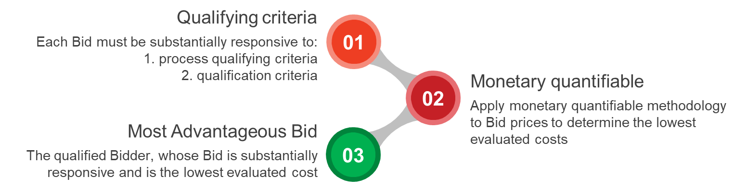
Figure XII – Example of the evaluation of RFBs

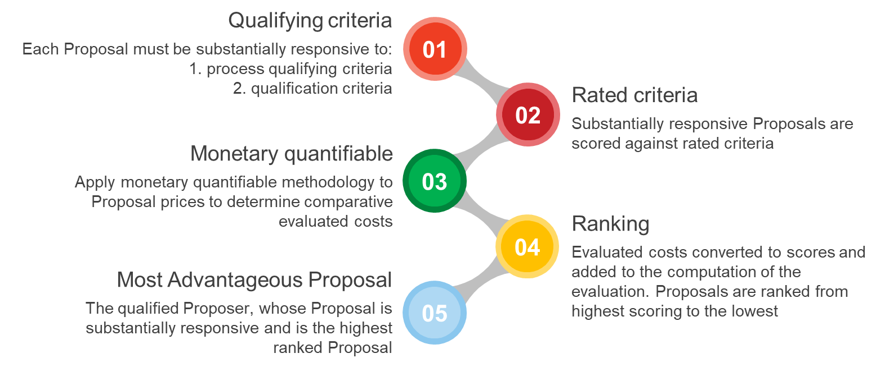
Figure XIII – Example of the evaluation of RFPs
The evaluation process is confidential and should not be disclosed to any persons not involved in the evaluation and award decision process until the Borrower’s intention to award has been transmitted to all Bidders. The Borrower prepares a report of the evaluation process and this report is subject to review by the Bank for procurements subject to the Banks prior review.

Decision to award and Standstill Period
Upon determining the most advantageous Bid/Proposal, the Borrower communicates its decision to all Bidders/Proposals that submitted Bids/Proposals. This is called the Notification of Intention to Award the contract. Issuing the Notification triggers the beginning of the Standstill Period. The Standstill Period last 10 Business Days and provides unsuccessful Bidders/Proposers an opportunity to seek a debrief, and/or submit a complaint about the decision to award the contract. The Borrower cannot award the contract until the expiry of the Standstill Period, or where a complaint has been lodged within the deadline, until the complaint has been addressed.
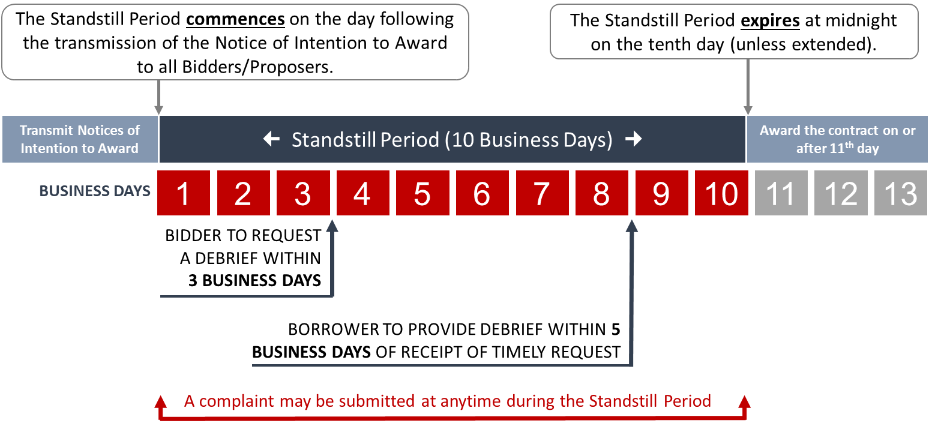
Figure XIV – Standstill Period timeline
Following the Standstill Period the Borrower publishes a Contract Award Notice on the UNDB website and the Bank’s website.

How to complain
The Bank focus is on good quality procurement done well. However, not everything always goes to plan. Sometimes your experience may not be what you expected.
If you have feedback or concerns about a procurement process, raise it with the Borrower directly. If you are not satisfied with the response, you may submit a formal complaint to the Borrower. The handling of complaints in relation to Operations Procurement is governed by the Procurement Regulations (see Procurement Regulations 3.26 to 3.31 and Annex III). The process is more fully described in specific guidance (How to complain) issued by the Bank Procurement-related Complaints.
It is important that Sellers have confidence that the Bank’s procurement procedures are followed, and that they have the right to challenge a procurement document, process or decision, where they feel that there has been a breach.
The approach to resolving procurement-related complaints has significantly improved because of the Procurement Regulations. To make it fairer to Sellers greater emphasis has been placed on managing complaints during the procurement process. In particular, the Standstill Period provides a pause in the process which allows Bidders the opportunity to seek feedback on why they have not been successful, and if appropriate, to submit a complaint in relation to the decision to award the contract. The award of contract cannot proceed until all duly submitted complaints have been addressed.

Beneficial Ownership
For the most significant procurements, before a contract is signed, the winning Bidder will be required to complete a standard template identifying beneficial owners, which are those individuals with a controlling interest in the company. Borrowers are required through Procurement Regulations to publish Beneficial Ownership information, together with other contract award information, on their websites, and the Bank will publish it on its own website. This information will not be routinely verified by the Borrower or the Bank. However, the Bank may conduct verification when triggered by integrity red flags, or in other cases when extended due diligence is warranted. The Procurement Documents issued by the Borrower will identify those contracts subject to the Beneficial Ownership requirement.

Direct Payment
In FY18, World Bank launched a Mandatory Direct Payment Pilot (Pilot), which helps facilitate payments to contractors. This Pilot is part of a broader Bank effort to foster competition in particularly difficult environments and will be monitored and evaluated for its effectiveness. When a project is subject to this Pilot, disbursement of Bank financing under contracts for Goods, Works, Non-Consulting Services and Consulting Services procured/selected through international open or limited competition, or through direct selection must be made through the Direct Payment disbursement method, unless a Special Commitment disbursement method has been selected. While the Direct Payment disbursement method has always been available, this Pilot makes it mandatory in the above described cases. The Pilot does not change how the World Bank processes withdrawal applications. Requests for Direct Payments will be disbursed by the World Bank to the contractor/supplier directly, after receiving a duly authorized withdrawal application and supporting documents from the country authorized official confirming the satisfactory receipt of Goods, Works and Services. The Procurement Documents issued by the Borrower will identify those contracts subject to the Direct Payment Pilot.

More information
Further information on Operations Procurement is provided in the Annexes. In particular Annex A describes tips for Bidding. Annex B provides Bidding checklists. Annex C is a summary of Operations Procurement data for the FY 2017. Annex D lists who’s who in Operations Procurement. Annex I provides links to sources of useful information.
An extensive library of good practice procurement guidance is also available on the Bank’s website covering such topics as VfM, evaluation criteria, competitive dialogue, complaints etc.
The Bank also regularly offers events for Sellers. These may be in the form of a public webinar, or a face-to-face business engagement event. To register interest contact mrivadeneira@worldbank.org or nbikondo@worldbank.org.
E-learning modules are also publicly available to those who wish to learn more about our Operations Procurement Framework. See www.procurementlearning.org

Section IV. Corporate Procurement

Section IV: Corporate Procurement

Overview
The World Bank Group (WBG) spends about US $1.7 billion dollars annually for Goods, Works, Consulting or Non-Consulting Services to meet its own business and operational requirements, including requirements funded by donor trust funds that support the WBG’s lending operations.
The WBG’s Corporate Procurement division is responsible for the coordination and oversight of the sourcing strategy, selection, and contract execution activities in all WBG offices around the world.
Positioned within the Strategy, Performance and Administration department, Corporate Procurement supports the WBG twin goals – to end extreme poverty and to boost shared prosperity, by streamlining spend on external goods and services while optimizing risks, capturing innovation, and ensuring social and environmental sustainability.
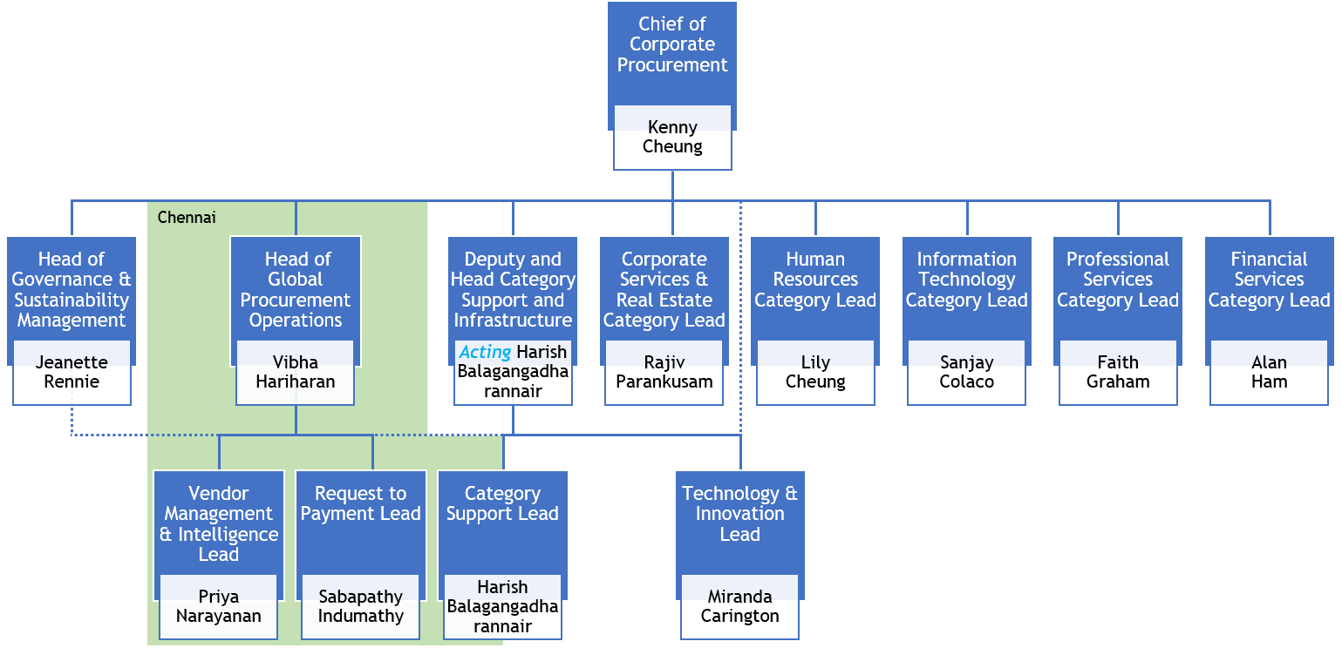
Figure XV - Corporate Procurement operating model

Targeting opportunities
Corporate Procurement utilizes category management concepts to foster early collaboration between the client department and procurement. This helps identify vendor innovation, facilitates better planning and early engagement. For a list of category management teams and contact points, see Annex H.
Solicitations for contracts valued at US $250,000 or more, and at US $50,000 or more in the case of operational consulting requirements, are advertised. Vendors should monitor these webpages for upcoming opportunities. To express interest in these business opportunities, interested Bidders must follow the instructions presented in the individual notices.
Interested Bidders are encouraged to review the information provided in the Corporate Procurement website before they submit a proposal to ensure that they will be eligible to register and become an approved World Bank Group vendor.
Business Opportunities main page:
http://www.worldbank.org/en/about/corporate-procurement/business-opportunities
Opportunities for Goods, Services, and Works:
http://www.worldbank.org/en/about/corporate-procurement/business-opportunities/administrative-procurement
Opportunities for Consulting Services to support WBG project work:
http://www.worldbank.org/en/about/corporate-procurement/business-opportunities/operational-consulting-opportunities

Corporate Procurement principles
The Corporate Procurement function is guided by the core principles of:
- Transparency;
- Fairness;
- Competition; and
- Best value.
In addition, Corporate Procurement is committed to:
- fair labor practices;
- appropriate wages and benefits;
- safety;
- environmental programs; and
- the diversity of Sellers.

Procurement policies and procedures
The Corporate Procurement Policy and Procedures Directive governs the procurement of Goods, Services, Works, and Consulting Services for the World Bank Group’s own requirements and for requirements funded by donor trust funds that go to support the Bank Group’s lending operations.
A policy summary is made available in the website to assist the vendor community understand how to do business with the World Bank Group. This policy summary contains key provisions of the directive and is made available to vendors at:
https://thedocs.worldbank.org/en/doc/190bc0e0c2ad9129a4d6be81cbc0fbcd-0180012019/original/Corporate-Procurement-Policy-Summary.pdf

Procurement process
While each procurement is unique, they broadly follow a similar process. Figure XVI shows the common stages of the procurement process and their usual sequencing.
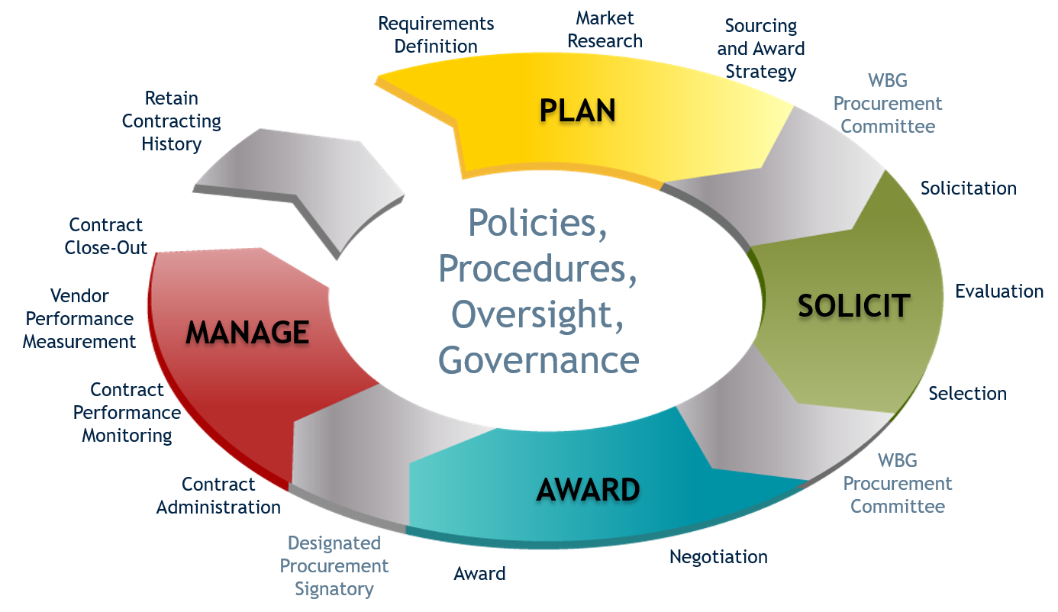
Figure XVI - Corporate Procurement Process

Sourcing methods
Acquisitions made by the WBG follow, whenever possible, a formal competitive Bidding process as required by the relevant policies and procedures. This is done either by invitation or advertisement, using a variety of traditional solicitation tools such as RFQs, Invitation for Bids (IFBs), RFPs, etc. Corporate Procurement uses electronic procurement systems for many of its requirements. The latter allows the WBG to increase process efficiencies while enabling transparency, fairness, and competition.

Participating in the solicitation process
All solicitations include information about the WBG business and technical requirements as well as the selection criteria. Information that may form part of a solicitation document includes specifications, the statement of work, terms of reference, the price sheets, relevant questionnaires, proposed contract terms and conditions, evaluation criteria, and any other necessary information.
Vendors should read the solicitation documents carefully as they will include specific instructions on (i) how to prepare their Bid/Proposal submission, (ii) the process for submitting the Bid/Proposal, and (iii) who to contact in case of questions regarding the solicitation. Time will be provided for vendors to submit questions or requests for clarifications. Some solicitations may include a pre-proposal conference. In such case, the solicitation document will state whether attendance is mandatory or not.

Disclosure of contract awards
Under WBG information disclosure policies, certain Corporate Procurement contract awards are eligible for public disclosure. When an award is disclosed, the following information is made available on the World Bank website:
1. the name of the vendor receiving the award
2. a brief description of the contracted Goods or Services
3. the contract award amount.
More information about the disclosure of Corporate Procurement contract awards is available at:
http://www.worldbank.org/en/about/corporate-procurement/business-opportunities/corporate-procurement-contract-awards

Vendor Risk Management
In today’s business environment, organizations with a global footprint are exposed to a myriad of cybersecurity threats, business disruptions, geopolitical issues, market fluctuations, reputational concerns, and other significant risks. Identifying and prioritizing the risks an organization chooses to focus on, is core to an efficient and smooth operation.
Through its Vendor Risk Management (VRM) program, Corporate Procurement identifies, mitigates, controls, and monitors the risks that are relevant to the WBG. In doing so, Corporate Procurement seeks to manage risk exposures across the WBG in a consistent, objective, practical, and sustainable manner. This encourages a better use of internal resources, improves efficiencies, and facilitates the achievement of the WBG institutional goals.

Business ethics
Corporate Procurement sets out minimum standards of conduct expected from WBG vendors, these are part of the Vendor Integrity Policies. Failure to comply with the Code of Conduct may preclude vendors from being eligible for a contract award or may result in a contract being terminated.
In addition to the Code of Conduct, vendors whose employees perform work on WBG premises are subject to the Code of Conduct for On-site Vendor Employees.
More information about the applicable Code of Conduct and related Vendor Integrity Policies is available at:
http://www.worldbank.org/en/about/corporate-procurement/vendors

Sustainable Procurement
The WBG Corporate Procurement’s vision recognizes sustainability as a core factor to become an efficient and effective procurement function. Sustainable procurement at the WBG encompasses the following areas:
Socially Responsible Procurement
As a socially responsible organization, the WBG, through its Corporate Procurement practices, endeavors to integrate socially responsible Sellers into its supply chain. To this end, Corporate Procurement solicitations and contracts for labor services will specify measures to be implemented to address service employees’ wages, their health and welfare fringe benefits, safe working conditions and fair and equitable work practices.

Environmentally Responsible Procurement
To increase the development and awareness of Environmentally Responsible Procurement (ERP), the acquisitions of Goods and Services will ensure that, wherever possible, specifications are written to provide for the expanded use of environmentally preferred products such as: durable products, reusable products, energy-efficient products, low-pollution products, products (including those used in services) that contain the minimum level of post-consumer waste and/or best recyclable content, and products that in any other way have a minimal harmful impact on the environment. Additionally, the creation and supply of services and products should consider global life-cycle impacts.

Supplier Diversity
At the WBG, we believe that a diverse supplier base benefits us by bringing different perspectives, innovative solutions, and a resilient supply chain. We are committed to promoting, increasing, and improving the business participation of Minority- and Women-Owned Business Enterprises (MWBEs) in our procurement process. For more information on the WBG’s Supplier Diversity program please visit:
http://www.worldbank.org/en/about/corporate-procurement/vendors/supplier-diversity

Eligibility
Vendors do not need to be a registered WBG vendor to participate in a solicitation process. To receive a contract award, however, the vendor must be registered. The WBG’s vendor registration process consists of completing an electronic vendor application form, meeting all eligibility requirements, and providing all required documentation. Vendors that have been determined eligible, and that have successfully completed the registration process will receive a Vendor Identification Number.
For more information about the Vendor Registration program and policies visit:
http://www.worldbank.org/en/about/corporate-procurement/vendors.
We recommend you take time to review all associated documents, especially those related to vendor eligibility.

How to complain
During a solicitation process, vendors should inform the Category Manager (identified in the solicitation document) if they believe the specifications or other solicitation requirements are faulty, unnecessary, or inhibit competition so that any valid issues can be addressed.
Award debriefing and protest procedures are described in detail in section 14 of the Corporate Procurement Policy Summary:
https://thedocs.worldbank.org/en/doc/190bc0e0c2ad9129a4d6be81cbc0fbcd-0180012019/original/Corporate-Procurement-Policy-Summary.pdf

Other information
See Annex E for tips for Bidding on Corporate Procurement requirements, Annex F for examples of what the World Bank Groups buys, Annex G for a summary of the spent for the FY 2021, and Annex H for areas of responsibility within Corporate Procurement and contact information.

Annex A. Operations Procurement – Tips for Bidding

Annex A.
Operations Procurement – Tips for Bidding

This Annex provides Sellers with general tips on how you can make your Bid for Bank financed Operations Procurement more attractive, starting from making a pre- Bid/Proposal visit, preparing a responsive Bid and what to check for at Bid opening among other things. See also Annex B for a useful Bidders checklist.
Preparing a Bid/Proposal
- Understand the procurement’s objectives and the procurement strategy the Borrower is using to select the Most Advantageous Bid/Proposal;
- Examine carefully the evaluation criteria, as this will be used to determine the Most Advantageous Bid/Proposal – if you can meet or exceed this then you have a good chance of winning if not, then consider carefully whether you should go to the time and expense of Bidding;
- Make a pre- Bid/Proposal visit (if indicated) on the date and at the venue(s) indicated by the Borrowers in the SPD;
- For Consultant Services - address Terms of Reference fully;
- For Goods, Works, and Non-Consulting Services you must respond substantially to technical specifications or your Bid will be disqualified;
- Where the evaluation criteria require that you explain the methodology that will be used to deliver the project, make sure you provide a full explanation of the processes, and in the level of detail required;
- Where the evaluation criteria awards extra points for innovation, provide a description of the type of innovation that you could bring to the project and how the project would benefit;
- Propose a strong Project Manager and qualified experts;
- Cite relevant technical and regional experience similar to the assignment – more significant and similar the better;
- Involve Borrower partner consulting firms or individual Consultants, consider joint ventures;
- Don’t deviate from SPDs/conditions;
- Get official clarification: If any provisions of the Bidding/Proposal document are unclear or unacceptable, submit an official inquiry in writing to the Borrower copy the Bank before the Bid closing date or such date as may be specified;
- Do not express any conditionalities, or qualifications will lead to rejection;
- Submit a professional, Bid/Proposal ensuring all supporting documents included, signed by authorized individual; and
- Carefully review qualification and evaluation criteria: Failure to satisfy qualification criteria (including SOE eligibility criteria) results in high Bid rejection rate.

Before submitting a Bid/Proposal:
The following aspects are the most common issues that lead to Bids/Proposals being rejected immediately. Please make sure you do not make a silly mistake that results in your Bid being rejected.
To make your Bid acceptable, it is important to perform final checks on the following items before Bid/Proposal submission:
- The amount, validity and text of Bid Security are correct; and
- Signatures are by a person who is authorized through a power of attorney.
- The Joint venture agreement is enclosed (if it is a Joint Venture Bid)
- References are enclosed and are relevant;
- Discounts are stated in the covering letter, or in an appropriate place as specified in the procurement document;
- Marking of envelopes is correct, using the appropriate term of “Technical” or “Financial” envelope; and
- You are clear when, where and how the final Bid/Proposal will be submitted, and you have organizational arrangements in place to meet these requirements.
At Bid/Proposal opening
During Bid/Proposal submission it is important to pay attention to the following issues:
- Be on time: Submit your Bid/Proposal within the stipulated deadline. Late Bids/Proposals will not be accepted;
- During a public Bid/Proposal opening, you can expect the following to happen:
- all relevant prices are read out;
- all discounts are read out;
- presence and amount of Bid security is read out;
- no envelope remains unopened;
- all the above is recorded correctly in writing; and
- the record is signed by all Bidders/Proposers present and by the Borrower’s implementing agency representative.
- Be aware of possible extensions: There may be a request to extend the Bid validity and Bid security periods by several months, where, for example, the evaluation of Bids requires more time than originally expected.

Annex B. Operations Procurement – Bidding checklist

Annex B.
Operations Procurement – Bidding checklist

To assist Sellers in Bidding, we suggest the following checklist is used. as part of your internal quality assurance process when Bidding/Proposing for Operations Procurements. Using these checklists will help to ensure you avoid the common mistakes Sellers sometimes make.
Checklist 1 - Preparing a Bid/Proposal:
Checklist | Check
Do you fully understand the procurement’s objectives?
Do you fully understand the procurement strategy for selecting the Most Advantageous Bid/Proposal?
Do you meet or exceed the qualification and evaluation criteria or not?
Have you arranged to attend the pre-Bid/Proposal meeting (if one is being held)?
For Consultant Services – did you address Terms of Reference fully?
For Goods, Works, and Non-Consulting Services, did you respond substantially to technical specifications?
Did you emphasize your methodology for delivery? Where innovation is requested, did you innovate if you could?
Did you propose a strong Project Manager and qualified experts?
Did you cite relevant technical and regional experience similar to the assignment?
Are you involving Borrower partner consulting firms or individual Consultants?
Have you considered joint ventures?
Are you proposing any deviation from SPDs/conditions?
Did you get any official clarifications if necessary?
Confirm there are no conditionality’s or qualifications?
Have you included all supporting documents required?
Has the submission signed by authorized individual?
Table III – Preparing a Bid/Proposal

Checklist 2 – Final check before submitting a Bid/Proposal:
Checklist | Check
Is the amount, validity, and text of the Bid Security correct?
Is the person signing authorized through a power of attorney?
If submitting a joint venture, is the Joint Venture Agreement enclosed?
Are all relevant references enclosed?
Are all discounts stated in the covering letter, or in an appropriate place as specified in the SPD?
Have all of the envelopes been marked correctly, using the appropriate term of “Technical” or “Financial” envelope?
Do you fully understand when, where and how the final Bid/Proposal will be submitted and have organizational arrangements in place to meet these requirements?
Table IV – Final check before submitting a Bid/Proposal

Annex C. Operations Procurement – Data FY 2021

Annex C.
Operations Procurement - Data for FY21

As at FY21 the World Bank funded over 1760 investment projects in 144 countries and procurement portfolio worth US $10 to 17 Billion annually. The following tables outline the key data of FY21 contracts by category and sector.
 | Number of Contracts | Value of Contracts
Works | 5,690 (19.31%) | 10,812 (63.10%)
Goods | 9,744 (33.03%) | 3,886 (22.68%)
Consultant Services | 10,956 (37.15%) | 1,953 (11.40%)
Non-Consultant Services | 3,083 (10.51%) | 484 (2.83%)
Totals | 29,473 | 17,135
Table V –Contracts by Procurement Category (US $ million, FY21)
 | Number of Contracts | Value of Contracts
Water, Sanitation and Waste Management | 5,065 (17.17%) | 5,429 (31.69%)
Transportation | 1,353 (4.58%) | 3,676 (21.45%)
Energy & Extractives | 1,357 (4.59%) | 2,983 (17.41%)
Health | 4,219 (14.35%) | 2,089 (12.19%)
Agriculture, Fishing & Forestry | 10,024 (34.02%) | 1,311 (7.65%)
Education | 2,052 (6.96%) | 412 (2.41%)
Social Protection | 1,653 (5.60%) | 410 (2.39%)
Industry Trade & Services | 1,313 (4.45%) | 388 (2.26%)
Public Administration | 1,978 (6.71%) | 340 (1.98%)
Others | 459 (1.56%) | 97 (0.56%)
Totals | 29,473 | 17,135
Table VI –Contracts by Sector (US $ million, FY21)

Annex D. Operations Procurement – Who’s who

Annex D.
Operations Procurement – Who’s who

It’s important to remember that the Borrower’s implementing agency should be your first point of contact for all questions on a specific project. However, you may occasionally need to seek clarification or guidance from World Bank Procurement staff.
You can contact any Bank staff member by:
calling: +1 (202) 473-1000
Operations Policy and Country Services Vice Presidency
OPCS Procurement: leads operational procurement policy matters, the Bank’s procurement framework, major procurement oversight, standard Bidding document development, and the Bank’s Industry Engagement Program (IEP). OPCS also supports webinars and various outreach events for Sellers interested in the Bank’s Procurement Framework and coordination with the other Multi-Lateral Development Banks.

Enzo De Laurentiis
Chief Procurement Officer – Leads and managers the procurement specialists in OPCS. Sets and manages the Bank’s Procurement Framework, and among other things accredits Procurement Specialists to operate, and chairs the Operations Procurement Review Committee.

Christopher Mark Browne
Lead Specialist – Industry engagement, business outreach, and complex technical procurement matters.

Tesfaalem Gebreiyesus
Lead Specialist – Standard Procurement Documents, Procurement Regulations, and complex operations matters.

Alexandre Borges de Oliveira
Lead Procurement Specialist – Supports policy development and implementation of operations.

Equitable Growth, Finance and Institutions Vice Presidency
Procurement Global
Leads implementation of the Bank’s Procurement Framework. Procurement Global contains the Operations Procurement specialists that support Bank Task Teams, and country capacity building activities – including many procurement reforms. Supports training and e-learning for Borrowers on the Procurement Framework.

Elmas Arisoy
Practice Manager - South Asia Region (e.g. India, Pakistan, Bhutan, Sri Lanka, Maldives, Afghanistan).

Kofi Awanyo
Practice Manager – East Asia Pacific - Mainland (e.g. China, Vietnam, Mongolia, Laos, Cambodia, Thailand etc.). Note: Kofi is based in the Bank’s Bangkok office.

Felipe Goya
Practice Manager – West Africa (e.g. Cameroon, Togo, Niger, Democratic Republic of Congo, Senegal). Note: International Procurements in this region are usually undertaken in French.

Simon Chirwa
Practice Manager – Europe and Central Asia (e.g. Poland, Kazakhstan, Turkey, Kyrgyz Republic, Georgia).

Snezana B. Mitrovic
Practice Manager & Global Lead - East Asia Pacific - Islands (e.g. Samoa, Indonesia, Papua New Guinea etc.). Also, the Global Lead for the Global Solutions Group for Building Procurement Systems team.

Hiba M. F. Tahboub
Practice Manager – East and Southern Africa (e.g. Uganda, Kenya, South Africa, Ethiopia).

Diomedes Berroa
Practice Manager - Latin America and Caribbean (e.g. Argentina, Mexico, Brazil, Colombia, Haiti). Note: International Procurements usually undertaken in Spanish or English.

Etel Patricia Bereslawski Aberboj
Practice Manager - Middle East and North Africa (e.g. Morocco, Egypt, Iraq, Yemen). Note: International Procurements usually undertaken in French or English.

Annex E. Corporate Procurement – Tips for Bidding

Annex E.
Corporate Procurement - Tips for Bidding

This Annex provides Sellers with general tips on how to prepare and submit a response to Bank Group Corporate Procurement opportunities.
  - Understand the procurement’s objectives and the procurement strategy being using to select the vendor;
  - Carefully review any mandatory qualification criteria: Failure to satisfy mandatory qualification criteria results in high Bid rejection rate;
  - Examine carefully the evaluation criteria, as this will be used to determine the selected vendor/solution – if you can meet or exceed this then you have a good chance of winning if not, then consider carefully whether you should go to the time and expense of Bidding;
  - Attend the pre- Bid/Proposal conference (if indicated) at the date and time stipulated in the procurement documents;
  - For Consultant Services - address Terms of Reference fully;
  - When applicable, concisely present and justify any modifications to the Terms of Reference you would like to propose on how to perform the assignment better and more effectively (e.g. deleting some activity that you find unnecessary, adding others or proposing a different phasing of the activities) as part of the proposal;
  - For Goods, Works, and Non-Consulting Services you must respond substantially to technical specifications or your Bid will be disqualified;
  - Emphasize your methodology for delivery/performance, this is usually a very important part of Bid evaluation and makes your Bid more or less credible – innovate if you can;
  - Propose a strong Project Manager and qualified experts;
  - Cite relevant technical and regional/global experience similar to the assignment – more significant and similar the better;
  - If references are requested, ensure they are relevant;
  - If presenting alternatives or equivalents, demonstrate that any proposed deviations are equivalent or superior to the WBG’s established requirements. Acceptance of such changes is at the sole discretion of the WBG;
  - Don’t deviate from the procurement documents/conditions;
  - Get official clarification: If any provisions of the Bid/Proposal document are unclear or unacceptable, submit an inquiry in writing to the Procurement Officer listed in the procurement documents at least 5 days prior to the Bid closing date or such other date as may be specified in the documents;
  - Do not express any conditionalities, or qualifications will lead to rejection;
  - If a Bid Security is required, ensure the amount, validity and text are correct;
  - Prepare a professional Bid/Proposal following the format specified in the procurement documents, ensuring all supporting documents are included and that your Bid/Proposal is signed by an authorized individual;
  - Ensure the marking of envelopes or electronic files is correct, using the appropriate term of “Technical” or “Financial” labeling;
  - Follow the instructions for submission of your Bid/Proposal – for example, if electronic submission is specified, or if hard copies are to be delivered;
  - Ensure you are clear when, where and how the final Bid/Proposal will be submitted, and you have organizational arrangements in place to meet these requirements; and
  - Confirm acceptance of non-negotiable and mandatory clauses of the WBG’s General Terms and Conditions. Requests for material changes to these clauses are at the sole discretion of the WBG and may result in the disqualification from the Bid.

Annex F. Corporate Procurement – What we buy

Annex F.
Corporate Procurement – What we buy

The World Bank Group purchases through its Corporate Procurement unit all Goods, Works, Consulting or Non-Consulting Services required for the operation of the institution. Some examples of these are:

Corporate Services & Real Estate
Includes construction and renovation, facilities management services, security services, printing and publishing services, shipping and logistics, good and conference services, and travel among other.

Human Resources
Includes health and wellness, medical benefits, recruitment services, labor services, training and leadership development, coaching, and emergency evacuation among others.

Information Technology
Includes hardware, software, cloud services and solutions, managed software solutions, ICT, financial services systems, and telecommunication equipment and services among others.

Professional Services
Includes operational & administrative consulting, advisory services, legal services and management consulting among others.

Financial Services
Includes insurance and brokerage, audit and accounting services and global payment services among others.

Annex G. Corporate Procurement – Data for FY21

Annex G.
Corporate Procurement – Data from FY21

The graph below illustrates the percentage of spent during fiscal year 2021 under the different Category Families.

Annex H. Corporate Procurement – Who’s who

Annex H.
Corporate Procurement – Who’s who

Overview
The Corporate Procurement team is comprised of Category Managers with specialized oversight on category areas such as Corporate Services and Real Estate, Human Resources, Information Technology, and Professional Services, and Financial Services.
These specialists understand their product categories and market trends and are responsible for the development of individual category strategies and fostering business partner and supplier relationships.
Contact us at:
corporateprocurement@worldbank.org
+1 (202) 458-5858
Kenny Cheung
Chief of Corporate Procurement

Rajiv Parankusam
Category Lead, Corporate Services & Real Estate – Construction and renovation, facilities management services, security services, printing and publishing services, shipping and logistics, good and conference services, and travel among other.

Lily Cheung
Category Lead, Human Resources – Health and wellness, medical benefits, recruitment services, labor services, training and leadership development, coaching, and emergency evacuation among others.

Faith Graham
Category Lead, Professional Services – Operational & administrative consulting, advisory services, legal services, and management consulting among others.

Alan Ham
Category Lead, Financial Services – Insurance and brokerage, audit and accounting services and global payment services among others.

Sanjay Colaco
Category Lead, Information Technology – Hardware, software, cloud services and solutions, managed software solutions, ICT, financial services systems, and telecommunication equipment and services among others.

Vibha Hariharan
Global Procurement Operations Lead – Vendor management, market intelligence, request to payment processes, and category support.

Jeanette Rennie
Governance and Sustainability Management Lead – Policies and procedures oversight, vendor risk management, sanctions process, sustainability program including diversity and inclusion, capacity building, outreach, and communications.

Annex I. Sources of useful information

Annex I.
Sources of useful information

- Procurement for Projects and Programs
www.worldbank.org/procurement
- Project Procurement App for iPad & Data on contracts
https://itunes.apple.com/us/app/world-bank-project-procurement/id911312962?mt=8
- Project Procurement APP: How to use the World Bank Project Procurement App
http://pubdocs.worldbank.org/en/433521492462144143/Procurement-App-Guidance.pdf
- Projects & Operations
http://projects.worldbank.org/
- Corporate Procurement
http://www.worldbank.org/en/about/corporate-procurement
- Project Procurement - Policies, Guidelines, Documents for Projects Before July 2016
http://www.worldbank.org/en/projects-operations/products-and-services/brief/procurement-policies-and-guidance
- New Procurement Framework and Regulations for Projects After July 1, 2016 http://www.worldbank.org/en/projects-operations/products-and-services/brief/procurement-new-framework
- World Bank’s Procurement Policy
https://policies.worldbank.org/sites/ppf3/PPFDocuments/Forms/DispPage.aspx?docid=4002
- World Bank’s Procurement Regulations for IPF Borrowers
https://thedocs.worldbank.org/en/doc/178331533065871195-0290022020/original/ProcurementRegulations.pdf
- Standard Procurement Documents templates
http://www.worldbank.org/en/projects-operations/products-and-services/brief/procurement-new-framework
- Guidance on SPDs:
http://pubdocs.worldbank.org/en/572311488224076481/SPDs-Guidance-FINAL.pdf
- Guidance on how to complain (Operations Procurement)
http://pubdocs.worldbank.org/en/975671478891365829/Complaints-Guidance-FINAL-Revised.pdf
- UNDB Online:
https://devbusiness.un.org/

For additional information, such as Standard Procurement Documents (SPDs), Guidance, briefing, training and e-learning materials see www.worldbank.org/procurement

Guarantees operations are excludes from Operations Procurement
Data is as of August 9, 2021.

