Example of decision logic

**Approved Selection Methods | Goods, Works and Non-consulting Services**

An example of decision logic when designing fit for purpose procurement processes

**INITIAL DECISIONS**

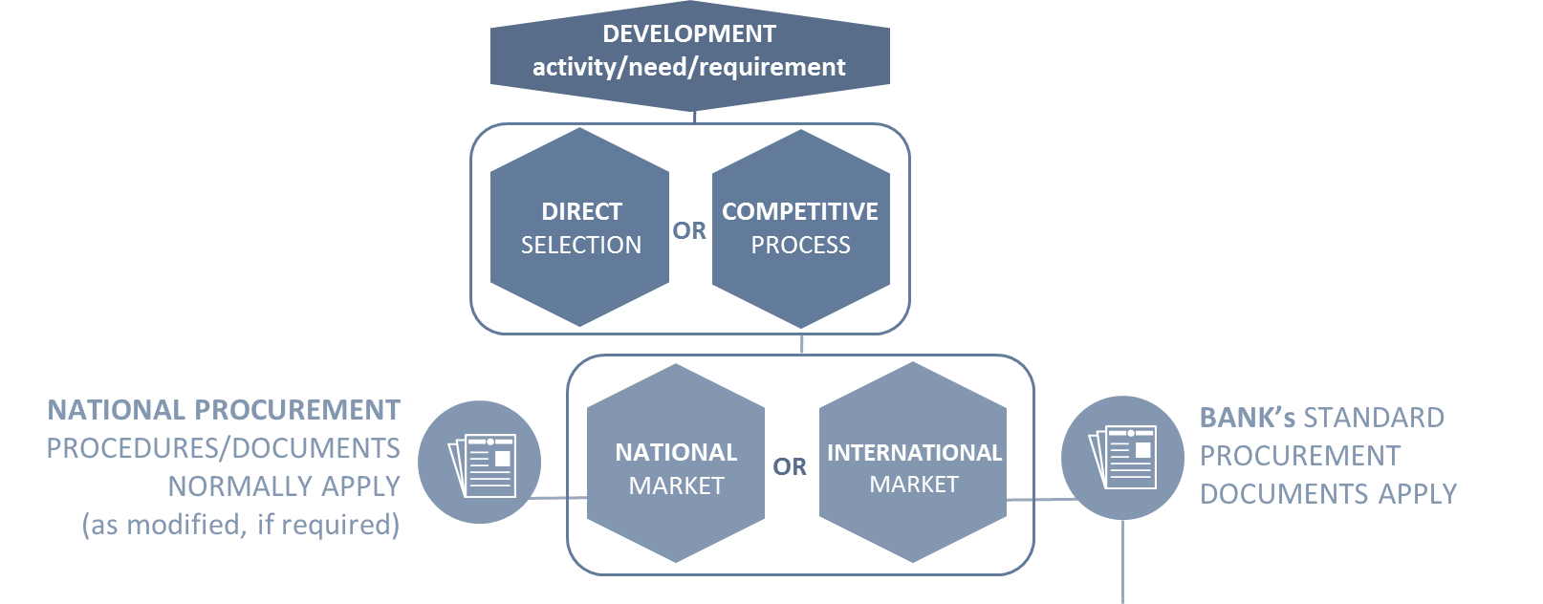









**RFP process**

(use IS unless good reason not to)

**RFB standard process**

**RFP process**

(use rated unless good reason not to)



The World Bank Procurement Regulations for IPF Borrowers

Approved Selection Methods Goods, Works and Non-consulting Services

PROCUREMENT REGULATIONS: SECTION VI AND ANNEX XII

HOW TO USE THIS TOOL

* This example of decision logic is a tool for practitioners. It provides a step-by-step approach to developing fit for purpose procurement processes. It helps work through the Approved Selection Methods for Goods, Works and Non-consulting Services (see Procurement Regulations, Section VI and Annex XII) to identify the appropriate Selection Method, Market Approach Option/s and SPD.
* While the example presents a logical sequence of choices it must be adapted to the context of each procurement. The actual sequence of choices may differ in practice. Effective market research and analysis, the size, scope and complexity of the procurement together with sound professional judgement will impact on how choices are made to determine the most appropriate approach.
* The example of decision logic supports good procurement practice. It is non-mandatory and provided as guidance only.

PROJECT PROCUREMENT STRATEGY FOR DEVELOPMENT (PPSD)

* Good procurement starts with good planning. The PPSD is the critical planning tool for Bank funded procurements. It informs many decisions about process.
* The PPSD captures the need, context, risk and key market analysis findings and explains how they:
  + impact on the Borrower’s approach to market, and
  + determine the best fit for purpose procurement process.

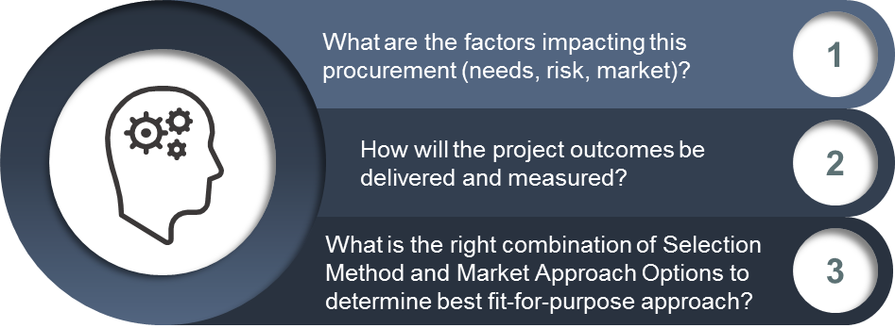

PROCUREMENT REGULATIONS FOR IPF BORROWERS

Section VI Approved Selection Methods for Goods, Works and Non-consulting Services – Table 1

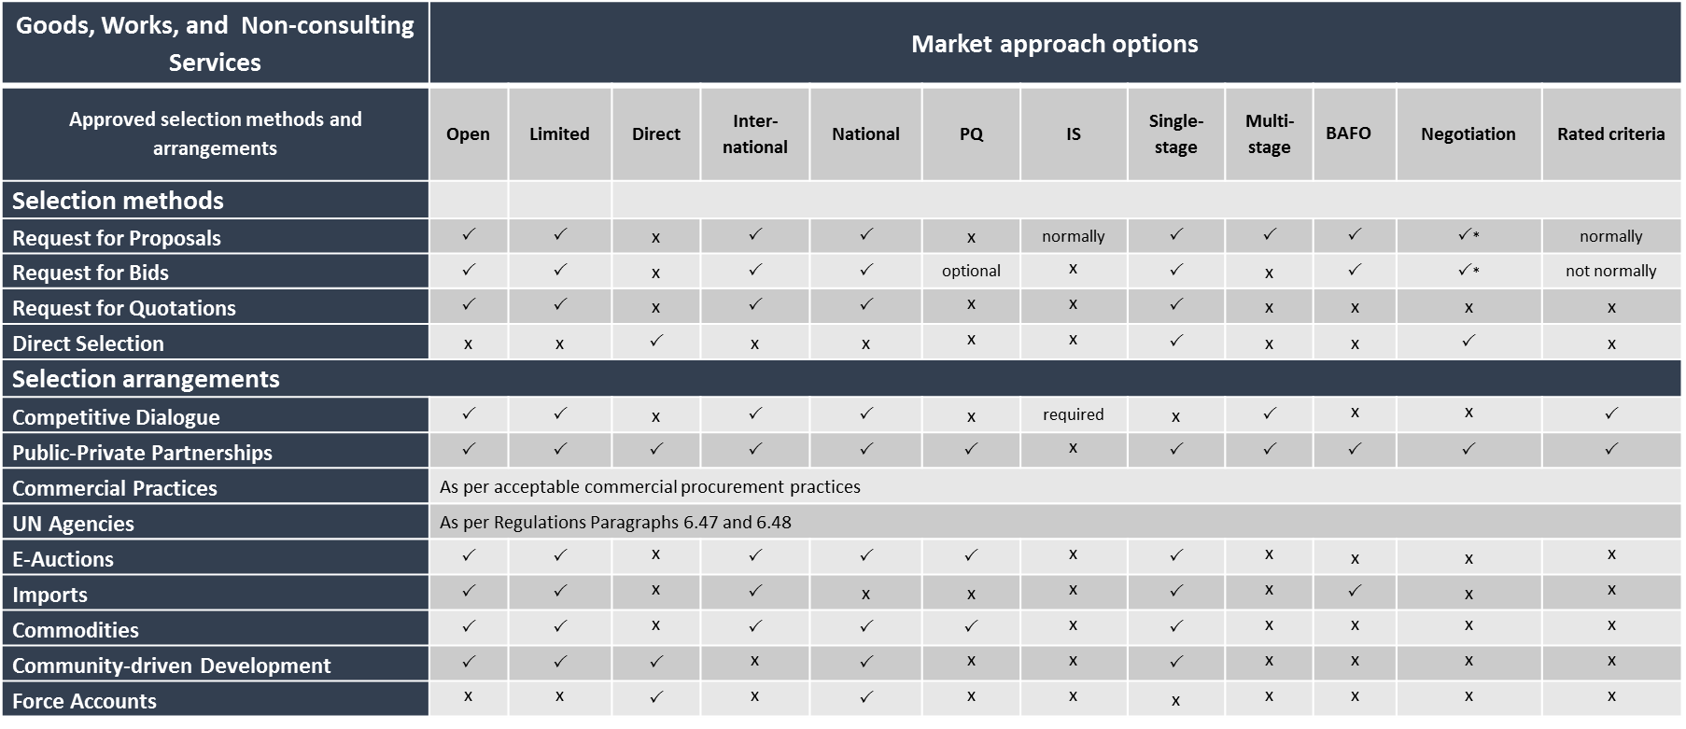



**The World Bank Procurement Regulations for IPF Borrowers**

Published 27 November 2016