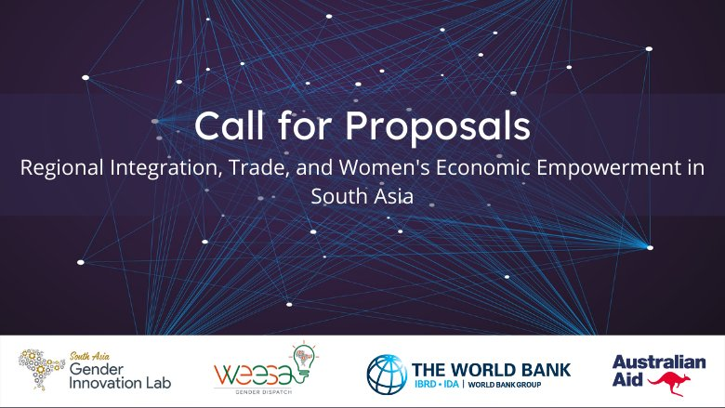

Proposal Template

Instructions

The template provides a suggested word limit for each section. Please keep to the prescribed word limit.

Wherever applicable, please provide relevant references and sources to substantiate your arguments.

Please provide resumes of all team members as separate attachments.

If you wish to provide any supplementary information regarding your technical approach, please use the annex provided at the end of this template.

Research implementation, expected outputs, and responsible researcher(s), must adhere to the following timeline:
  - October 15, 2022 : research plan
  - November 15, 2022 : interim update
  - December 15, 2022 : interim update
  - January 30, 2023 : first draft of research paper
  - February 28, 2023 : final research paper

Submit the proposal to sargenderlab@worldbank.org by September 27, 2022 at 5:00 PM Eastern Time.

We look forward to receiving your research proposal.

About the research team

Primary contact person:
Name of primary contact:
Institutional affiliation:
Nationality:
Current address:
Email id:
Phone:
3 references (name, designation, email id and contact number):

Details of other team members (if any):
Serial no. | Name | Institution of affiliation | Nationality | Current address
(Add more rows if required)

Technical Approach

Research title (~ 25 words)

Motivation and context (~ 500 words)
(Describe the motivation for the topic, current knowledge gaps that the research aims to address, and how it contributes to the existing literature)

Relevance (~ 500 words)
(Describe its relevance to the themes of regional integration, trade and women’s economic empowerment)

Research objectives and key research questions (~ 500 words)
(Describe the research objectives, key research questions and hypotheses)

Methodology (~ 500 words)
(Describe the Analytical approach and methodology, including datasets to be used in the analysis (if any) and rationale for using the selected methodology.)

Value-add and potential impact (~ 500 words)
(Explain the policy relevance, value added, and potential development impact of the research.)

Workplan and estimated days of effort (~500 words)
(Brief timeline of activities, interim milestones, and deliverables, along with breakdown of total days for every activity for each team member.)

Annex (optional)
( Please use this section to provide any additional information you would like to share.)

Annex 1: …..

Annex 2: …..

