QCBS EOI Evaluation Report
Consulting Services:

Contract reference:
Project:
Procurement Method:
Quality Cost Based Selection (QCBS)

TABLE OF CONTENTS

SECTIONS
SECTION 1 BACKGROUND
SECTON 2 EXPRESSION OF INTEREST
SECTION 3 EVALUATION
SECTION 4 RANKINGS
SECTION 5 RECOMMENDED SHORTLIST

SECTION 1. BACKGROUND
1.1 Objective and Scope
SECTION 2. REQUEST FOR EXPRESSION OF INTEREST.
2.1 Expression of Interest (EOI) Data.
The REOI was advertised starting from …. until …. through the WB Project website:

Eleven EOIs were received by the deadline as follows:
 | Country | Company
1
2
3
4
5
6
7
8
9
10
11

All consultants were checked against the World Bank Listing of Ineligible Firms and found to be eligible.
SECTION 3. EVALUATION
3.1 An Evaluation Panel of three (3) persons was established to evaluate all EOIs. They were:
1.

The orientation to evaluators was held on ….., and the evaluation of the EOIs was conducted on the following day. The evaluators were briefed on the principles of QCBS evaluation, including conflict of interest and confidentiality. All evaluators signed the confidentiality declaration. Refer to Annex A—Supporting Document Files.
Evaluators were provided with an electronic evaluation grid containing the evaluation criteria using a point score supported by a Strengths and Weaknesses Summary. The criteria used for Evaluation purposes are shown below.

EOI Evaluation Criteria |  | Strengths | Weakness

Using the criteria above, all Evaluators were asked to assess and rank each EOI. They were asked to include comments for the Strengths and Weaknesses for each EOI. Criteria were tabulated numerically to give a score for each candidate. The numerical score was used as a guideline only for reconciliation, in case of wide discrepancies between Evaluators. A Sample of the Evaluation Spreadsheet is shown below.

TABLE 3 - Sample Evaluation per EOI, per Evaluator
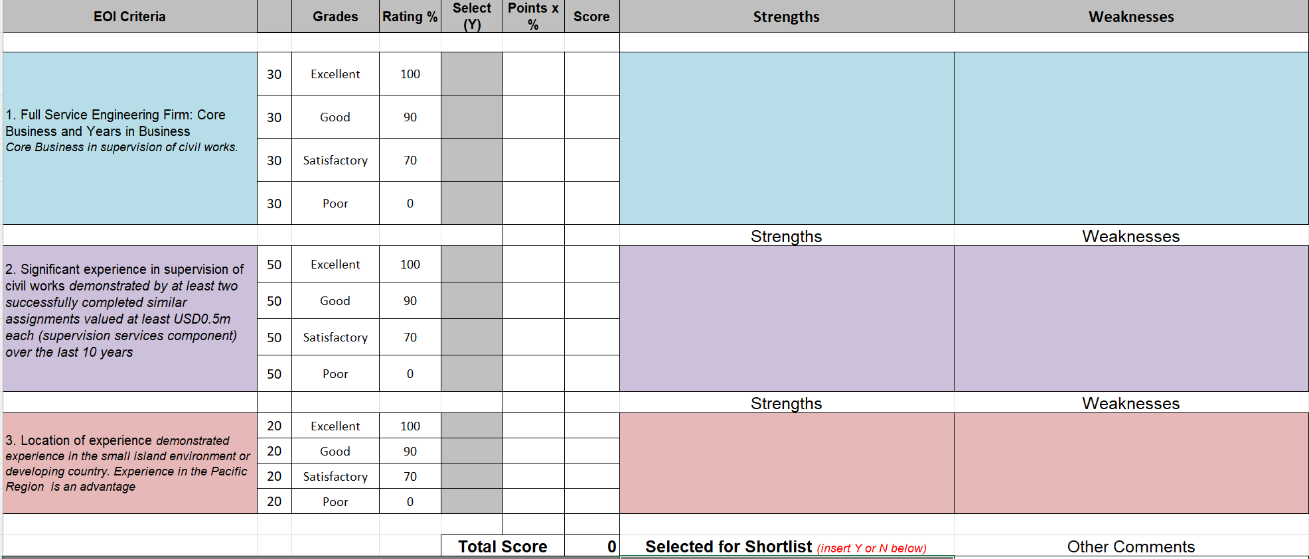

SECTION 4. RANKINGS
Evaluators used their Strengths and Weakness (S&W) summaries supported by the point scores to establish (their) shortlists.
It should be noted that each EOI was examined to identify the consultant (single company or association and the type of association (Consortium or sub-consultancy). In case of sub-consultancy, the capabilities and experience of the sub-consultant were not taken into consideration during the evaluation unless firms are in a Joint Venture. CVs of the personnel, if included in the EOI, were not considered.
The consolidated scores for each consultant are presented below:
Table: 4 Evaluation and Rankings
Country | Firms | Tony | Charles | Lanieta | Average Score | Rank

TABLE 6– Strengths and Weaknesses of the evaluated Consulting Firms
(Ranked 1st – points) – SHORTLISTED.
CRITERIA | STRENGTHS | WEAKNESSES

(Ranked 2 – points) – SHORTLISTED
CRITERIA | STRENGTHS | WEAKNESSES

GHD (Fiji) Pte Limited (Ranked 3rd – 93 points) – SHORTLISTED

(Ranked – Points) – NOT SHORTLISTED
CRITERIA | STRENGTHS | WEAKNESSES

– Not Shortlisted
CRITERIA | STRENGTHS | WEAKNESSES

SECTION 6. RECOMMENDATION FOR SHORTLIST.
The evaluation panel recommends that the following top eight (8) shortlisted consulting firms are eligible for the next stage.

Final Shortlist
Country | Firm | Ranking

Signatures of the Evaluation Panel

Annex A - Supporting Documents
ITEM | ACTIVITY | REFERENCE DOCUMENT
1 | ToR
2 | Evaluators Assessment Sheets
3 | CoI
4 | EOIs

